# Setting up a Java Development Environment

The javac compiler will convert the hello.java class in java byte code. The java byte code is system independent, in order to run this byte code we will be needing Java Standard Edition (SE) APIs and Java Virtual Machine (JVM).

JDK involved below things –

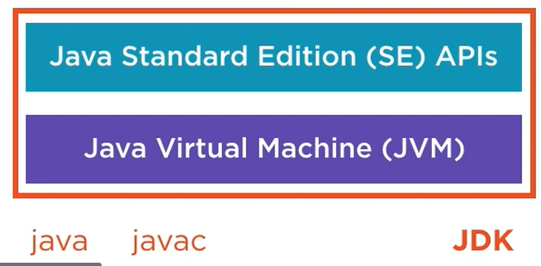

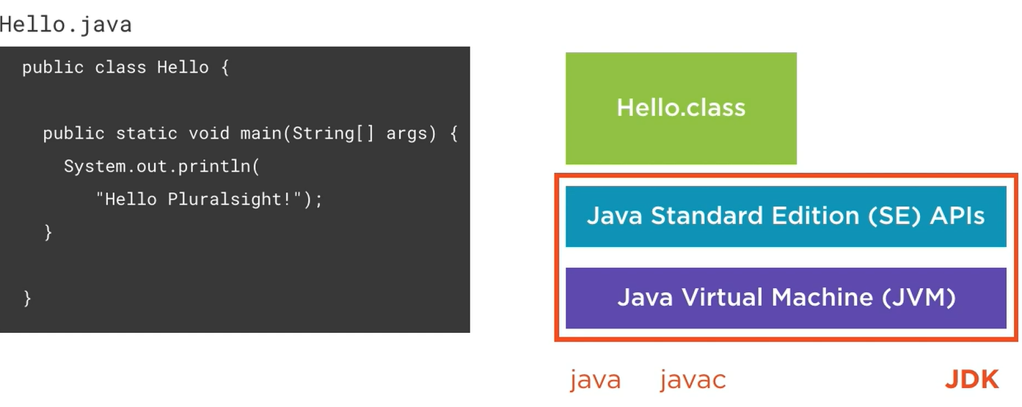

There is another thing called Java Enterprise (EE) APIs edition, these libraries are geared to web application development and enterprise application integrations and database access. Meanwhile JA SE edition edition APIs are more foundation APIs like networking, file access, creating and managing collections, etc. Java EE edition is not a part of JDK. Oracle has donated all the EE libraries to Eclipse foundation which lives on as Jakarta EE.

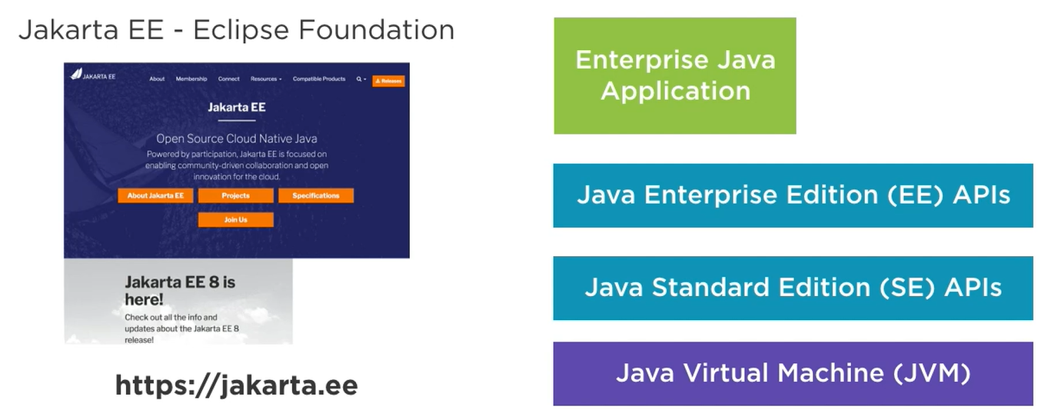

After downloading the JDK, we need to the JAVA_HOME environment variable, it should point to the JDK folder and gets used by many tools that use Java. We also need to update the OS system’s PATH variable to include the directory of the JDK that contains tools like the Java compiler and the Java runtime so that we can use it from the command prompt or shell anywhere.

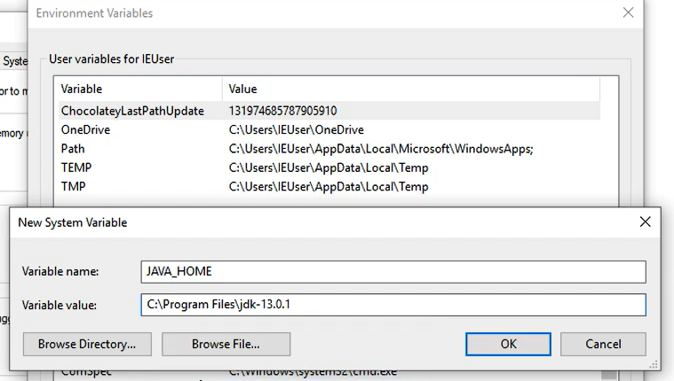

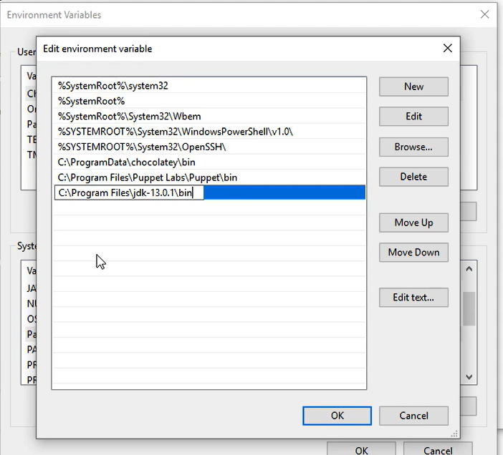

Popular Java IDEs – JetBrains IntelliJ Idea, Eclipse, Apache NetBeans.

The IntelliJ community edition is also the basis for the Google’s Android Studio for Android app developments. It used to be earlier Eclipse based, but now they have switched to IntelliJ.

Package name follows reverse-DNS naming conventions.

Java applications are packages into JAR files where JAR stands for Java Archive. It is simply a zip file containing our application classes in form of compiled code in byte format. This JAR file also contains metadata stored in a MANIFEST.MF file.

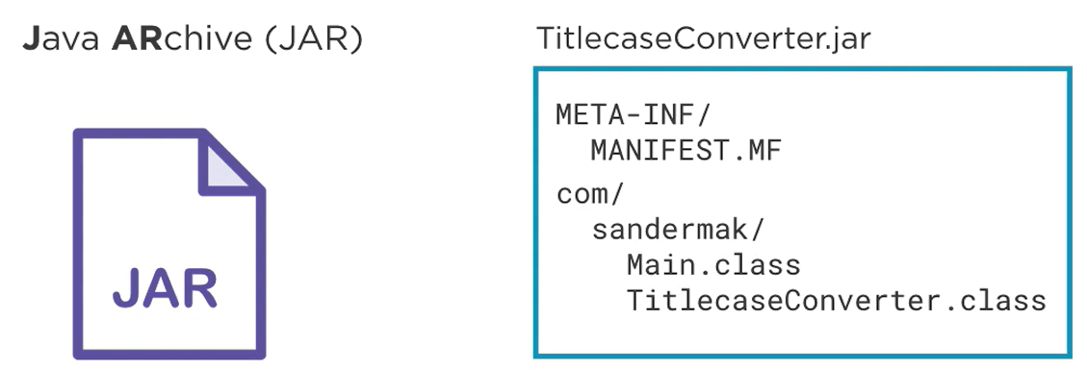

By using tool called “jar” in JDK we can create JAR files.

We metadata we also need to put which class is having main method so that JVM can invoke it properly –

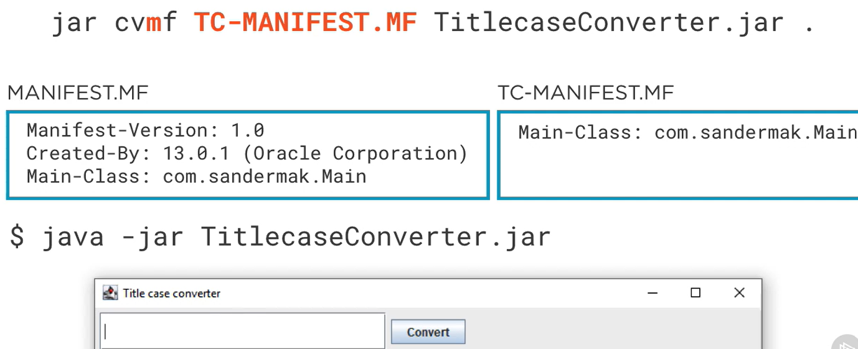

Creating JAR file through IDE –

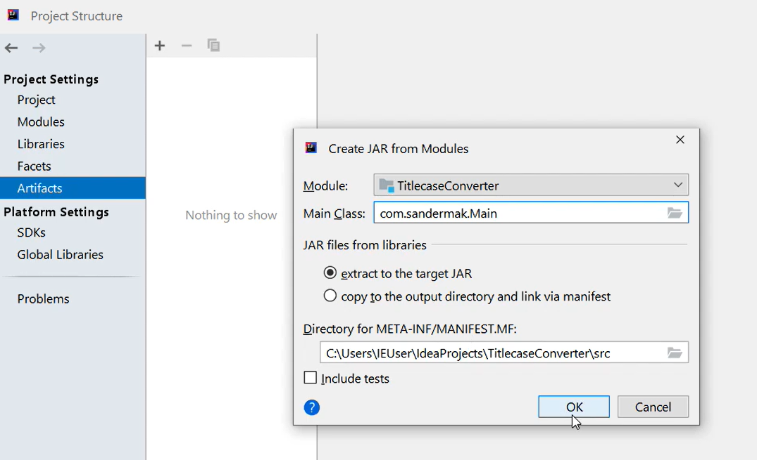

Instead of creating the JAR file manually through CLI or IDE, we generally use build tools like Maven or Gradle which have these steps to release a new package of the Java code – build -> test -> analyze (static code analysis) -> creating package.

# Modern Java: The Big Picture

Name JavaScript was only used by Netscape, which put JavaScript into the browser in the 90s to ride the surge of interest at that time in Java. Official name of the JavaScript is ECMAScript. Java belongs to Oracle, originally created by Sun Microsystems in the 90s, Oracle acquired Sun Microsystems.

The Java Platform includes programming language as Java, Runtime environment for CPU architecture independent and a standard library. All three are released under Java Development Kit (JDK).

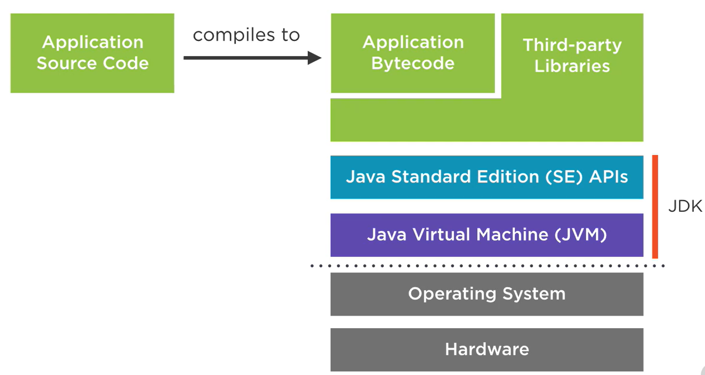

Philosophy of Java – WORA (write once run anywhere, optimized for readability – reading code is more important than writing code. Maintainability over terseness. Understandable code over clever code, it also followed controlled deprecation.

Java achieved Portability by having JVM for each OS/architecture. Java SE APIs platform-agnostic.

Java driven by Java Community Process (JCP).

Java Classes can be clubbed into Packages and Packages further can be clubbed into Modules.

The JVM takes care of scheduling the operations on the different threads to different CPU cores.

With Java we have the platform-independent byte code and a platform-specific JVM to do just in time compilation for better performance for that specific underlying hardware.

Java is not suitable for real-time systems due to garbage collection like auto driving car, tight with operating system integration which need low level system access instead of this use C or C++, for quick prototyping.

Java syntax inspired by C language.

As python is an interpreted language, it runs slower than Java. Python can be a great fit for developing smaller applications or quick prototypes where performance is not of the utmost importance.

JavaScript was born as a language in the browser, however combining JavaScript with Node.js gives a same managed platform as Java and C#. Node.js took JS out of the browser onto service. Node.js provides a standard library and execution environments for JS on the server.

The computational model of JS and Node.js is inherently single-threaded. So if we want to fully use a multi-core machine using JS and Node.js, we need to launch multiple processes, and coordination between different processes is harder and more expensive than coordination between threads in Java.

Desktop java – initially AWT (Abstract windowing toolkit) was launched to design desktop applications, afterwards Swing was released which used pure Java GUI instead of OS native controls, after this JavaFX has been released which provided the XML based, declarative format for UIs called FXML and provided the advanced UI components with animation and effects and 3D graphics, now it is a part of OpenJFX.

Enterprise Java (Java EE) – in enterprise applications we typically have web front ends, transactional database access, integrations with all kinds of different systems, scheduled tasks, and so on. The Java EE provides these libraries without manually choosing them externally to avoid complexity and increase the productivity of the developer. It offers a set of interoperable enterprise APIs for common enterprise applications tasks.

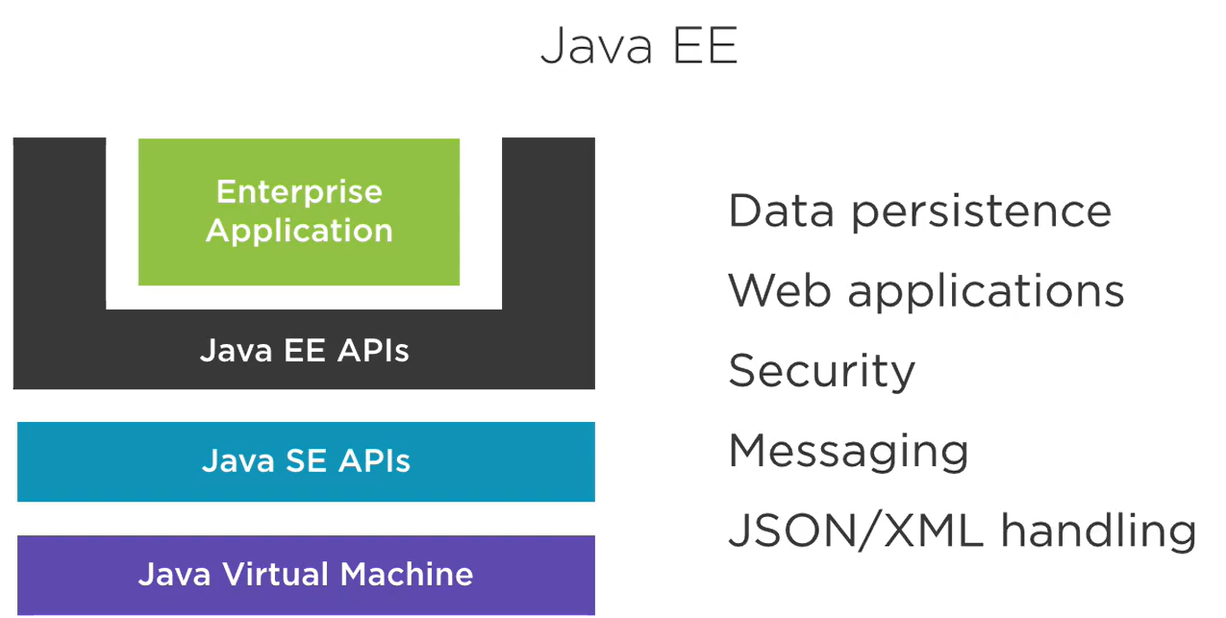

An application server is a container that runs on top of the JVM that can host Java EE applications. 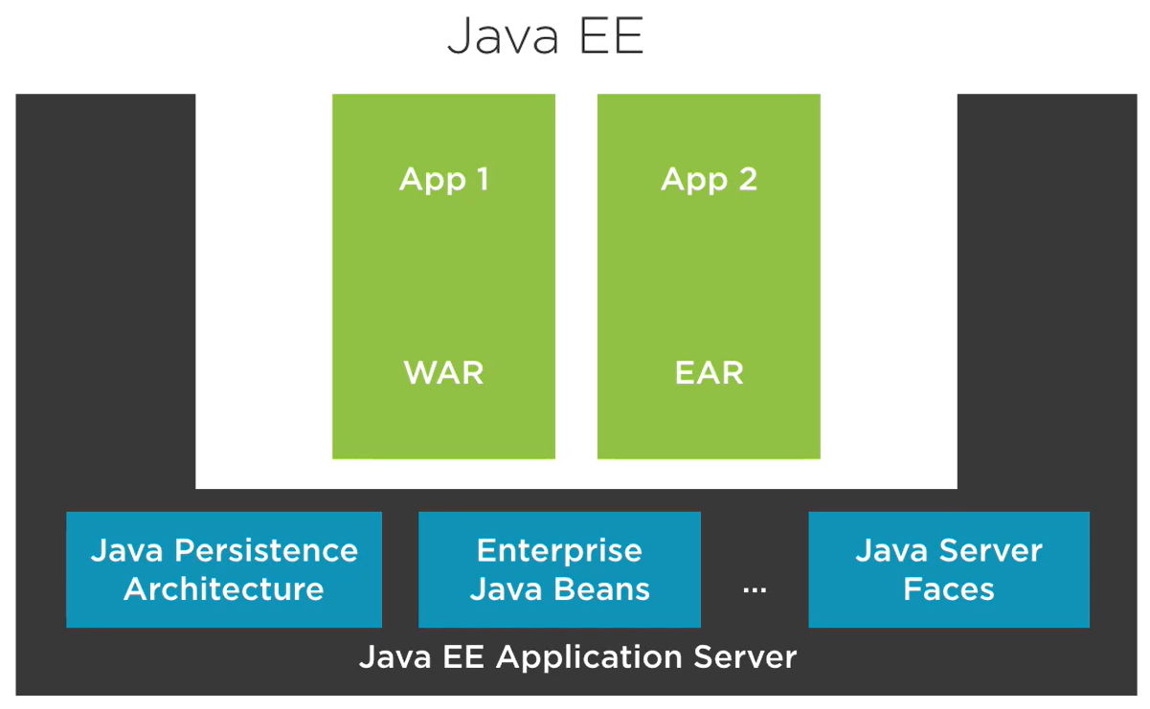

Java EE application servers – Wildfly (Red Hat), WebSphere (IBM), WebLogic (Oracle), Tomcat (Apache).

A competitor to Java EE, called Spring Framework.

Java in the Cloud – we use microframeworks to develop the application for Cloud and one of the popular frameworks is Spring Boot. Spring Boot is built on top of the Spring Framework and other Libraries that offer solutions for problems that we have in the cloud. It uses libraries from the Netflix open-source deck. Netflix is one of the poster children for microservices architectures, they offer components for service discovery, fault tolerance, and everything that is important in a cloud microservice architecture.

When we develop a spring boot application, ultimately everything is bundled up into a single Java application that runs on top of the JVM. There is no big application server involved anymore. Other popular micro frameworks are MicroProfile, Vert.x and Play Framework.

Android – Java is a primary language for writing Android applications. For Android the Java Bytecode converted into DEX (Dalvik Executable Format) which gets run on the Android platform. Android only supports older Java versions and a subset of the Java SE APIs. The DEX code is executed by Dalvik Virtual Machine instead of JVM which have different design goals like low power consumption of mobile phones.

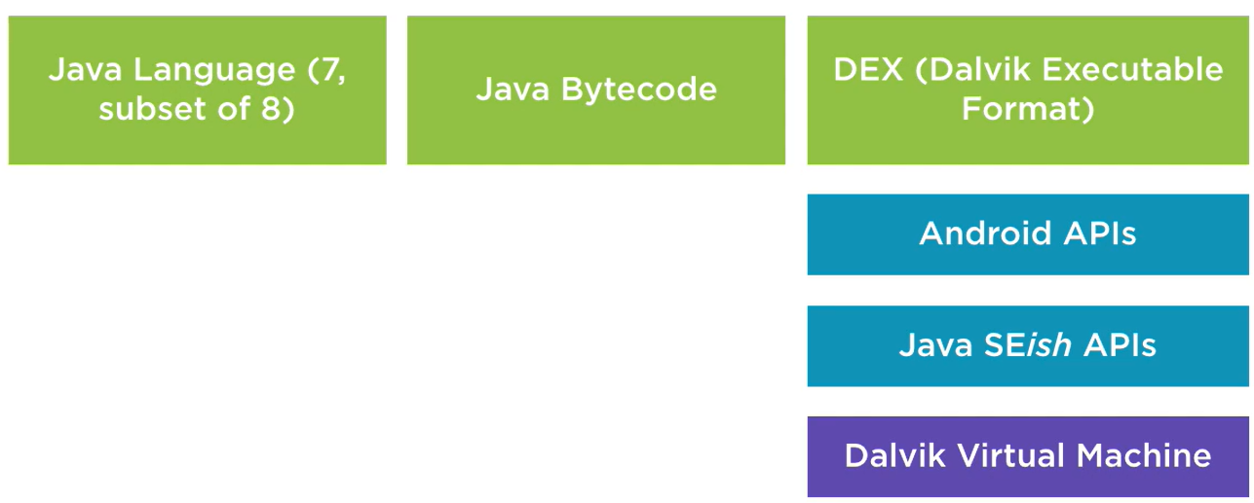

Popular Java Libraries – EJBs are the way to structure business logic in Java EE applications. Spring framework sort of emerged as a “rebel” framework pitting itself against entrenched Java enterprise development practices. We can read more in the book “J2EE Development without EJB” by Rod Johnson.

In Java EE application we can use Enterprise Java Beans to create transactional business logic. We can use Java Service Faces (JSF) to create web front ends. It is a very lighter alternative, it introduced the dependency injection (inversion of control), which is based on don’t call us, we will call you. The spring framework, at its core, is a dependency injection container that wires together the classes of our application based on instructions we provided. Sprint is just a framework which governs the structure of our application.

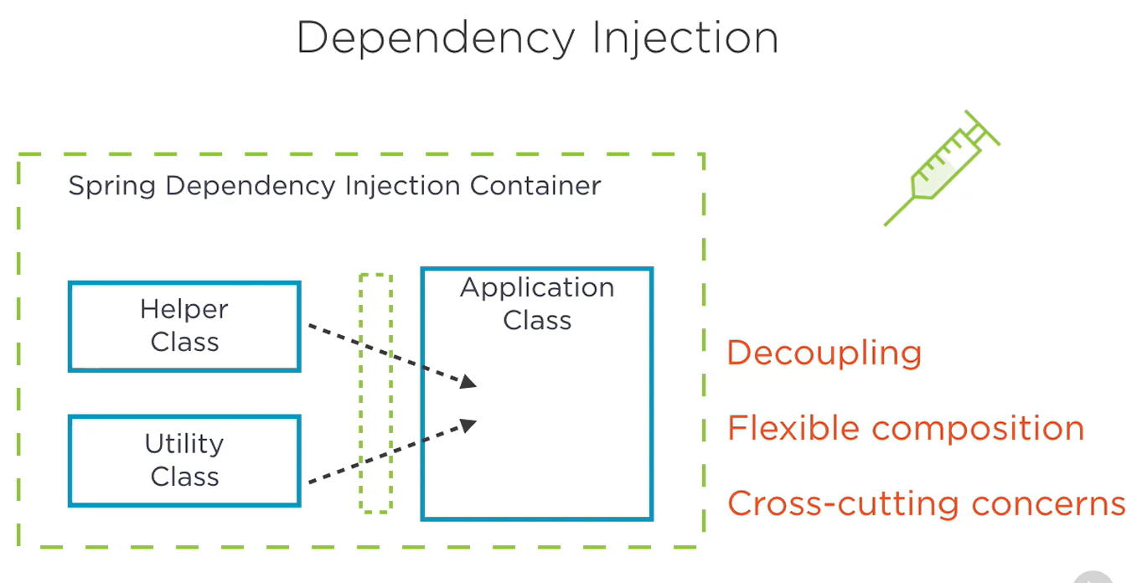

Other commonly used libraries – Google Guava, Apache Commons, Apache Log4J, Netty, Akka, RxJava, Apache Camel (enterprise application integration), JDBC, Hibernate and EclipseLink are ORMs by which we don’t have to write the SQL queries anymore but Java objects.

There are two approaches to design Java JPA (Java Persistent Architecture) by using ORMs or SQL DSLs –

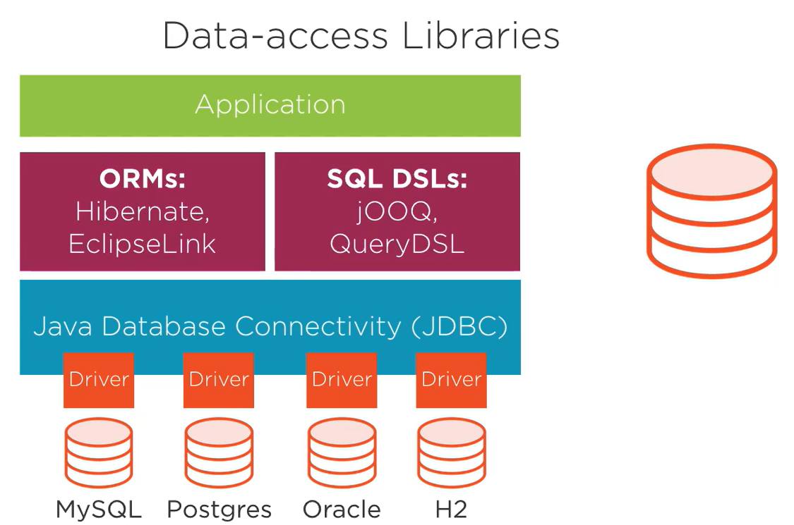

Java-based Data Processing libraries – Apache Hadoop, Apache Spark, DL4J (deep learning for Java), Cassandra, Neo4J (graph database), ElasticSearch, HDFS.

For unit testing we use Junit and Mockito.

With Maven we describe our builds in an XML file called pom.xml

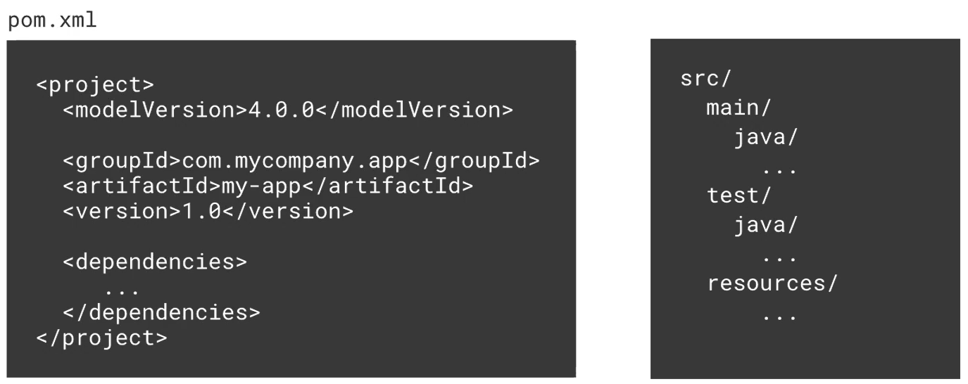

Build tools – Maven, Gradle. Gradle supports incremental builds and uses Groovy scripts. Gradle is a default-built tool for the Android applications as endorsed by Google.

Continuous integration and quality control – one popular CI server is Jenkins.

Static code analysis tools for Java – Checkstyle, Spotbugs (byte code level), PMD (source code level), SonarQube (more advanced tool).

Other than Java we can use alternative JVM languages like Groovy, Scala, Kotlin, JRuby and JPython.

Kotlin is a “better Java” designed by JetBrains company, it is also endorsed by Google for Android development. Kotlin can compile into byte code and as-well in JavaScript code so we can target both browser and mobile platforms.

# Maven Fundamentals

Maven is one of the main ways in which we build and configure our code in Java.

Maven 3.9 and Java 21 versions.

Different configure build tools – Maven, Ant and Gradle.

It is just a build tool which build code and produce an artifact, it produces only one output i.e. artifact we can call it component or JAR file as-well. It also manages all our dependencies of our project, also manage versioning/releases of our code. It can also use to produces Javadoc/site information.

Maven’s own by Apache Software Foundation. It is open-source software.

Why to use it – repeatable builds (primary needs for cloud deployment and docker), transitive dependencies, environment, works with local repo (means download once and reference it into different project hence save disc space and overhead), preferred choice for build tool like Jenkins.

Ant build tool – replacement for Make, cross platform, Java and XML based. For Ant we need explicit code for everything. Each organization has their own standards so very less structure and reused.

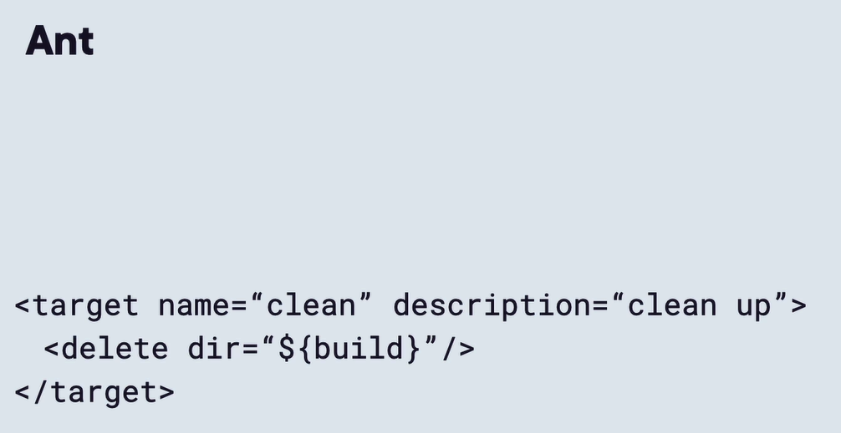

Maven – fully featured, implicit functionalities, consistency, inheritance through parent pom files, transitive dependencies (if pulling a JAR will going to pull in all the JARs that it needs to work within in application), versioned (based on snapshot).

Pros and Cons of Maven vs. Ant –

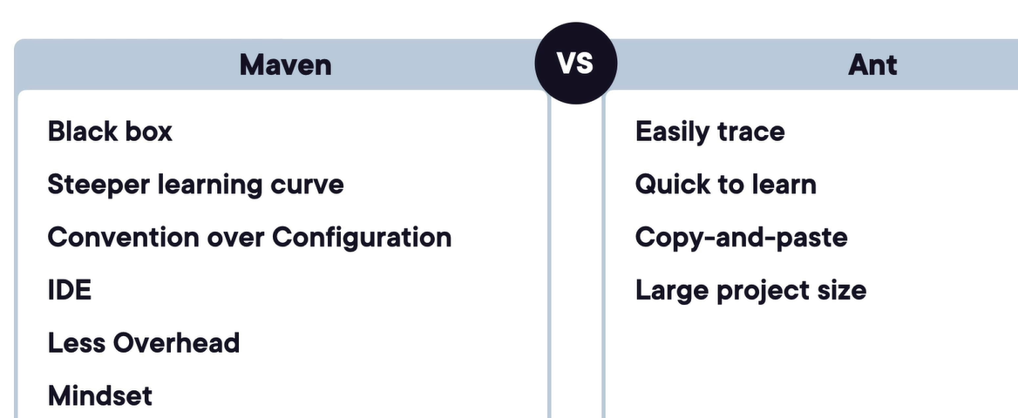

Basic script file in Ant for clean, compile and build –

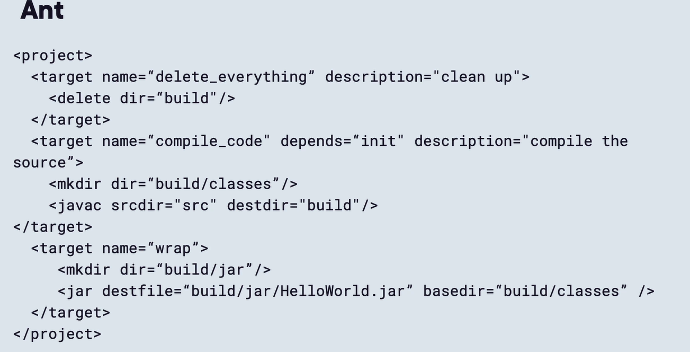

Sample Maven POM file – convention over configuration

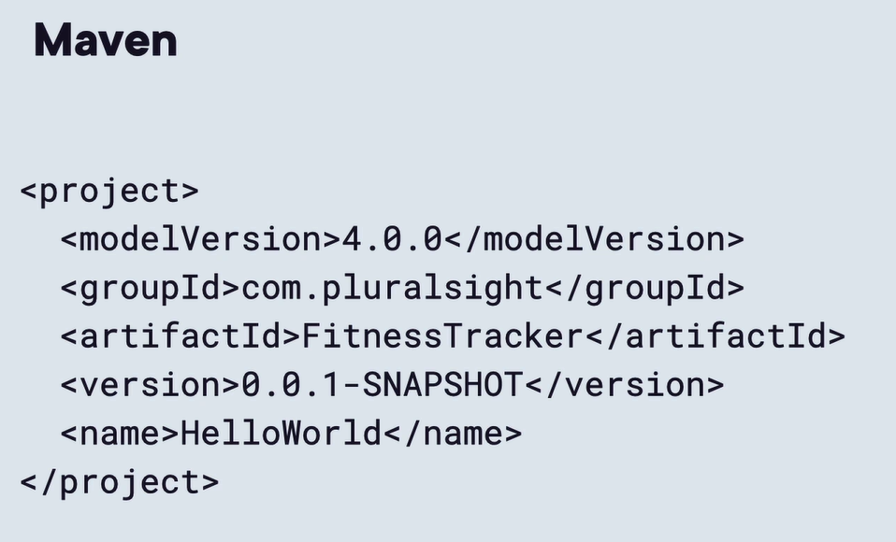

Gradle – Gradle is essentially Maven without the XML. It is YAML based and have same functionality as Maven. Sample Gradle POM file –

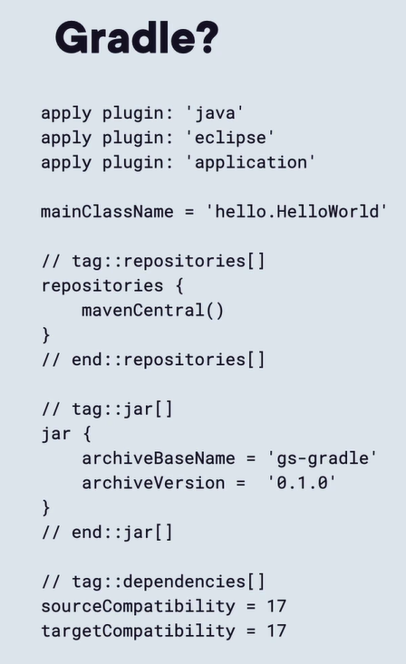

Create two environment variable name by JAVA_HOME and MAVEN_HOME –

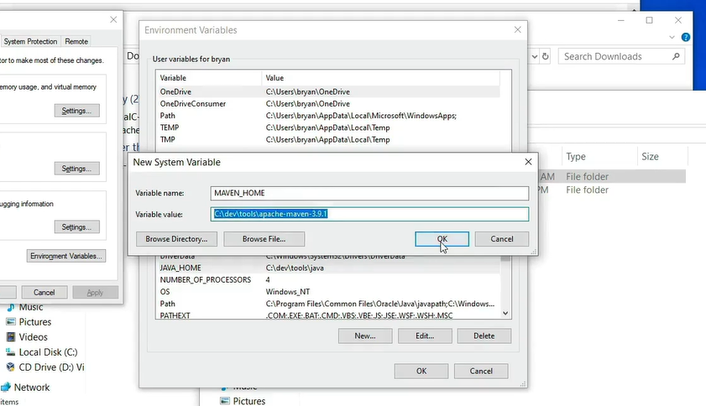

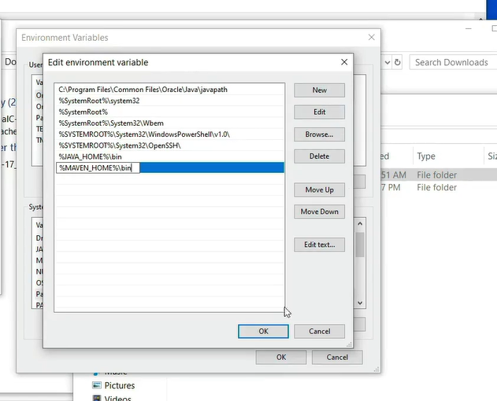

We can see these path variables by typing “set” in the cmd –

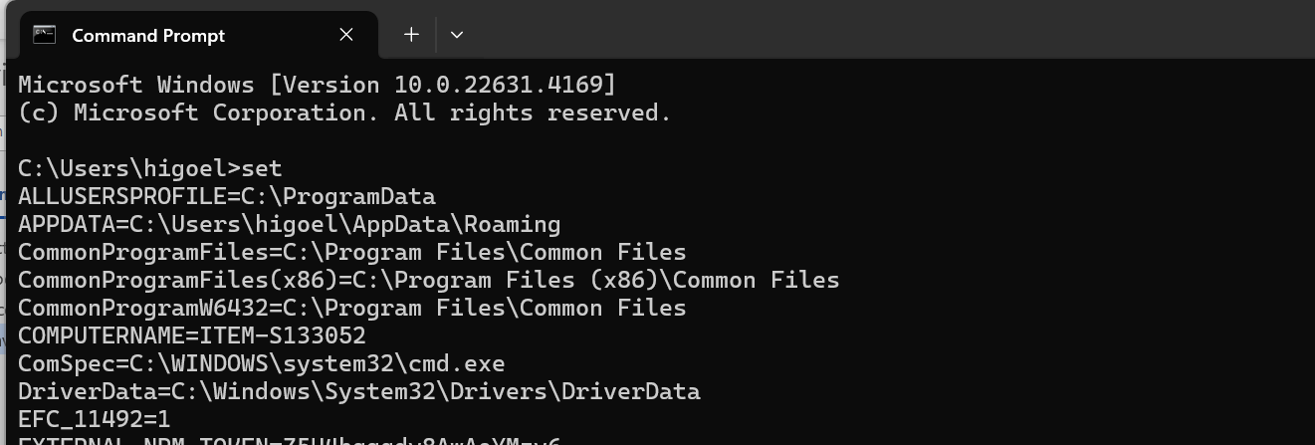

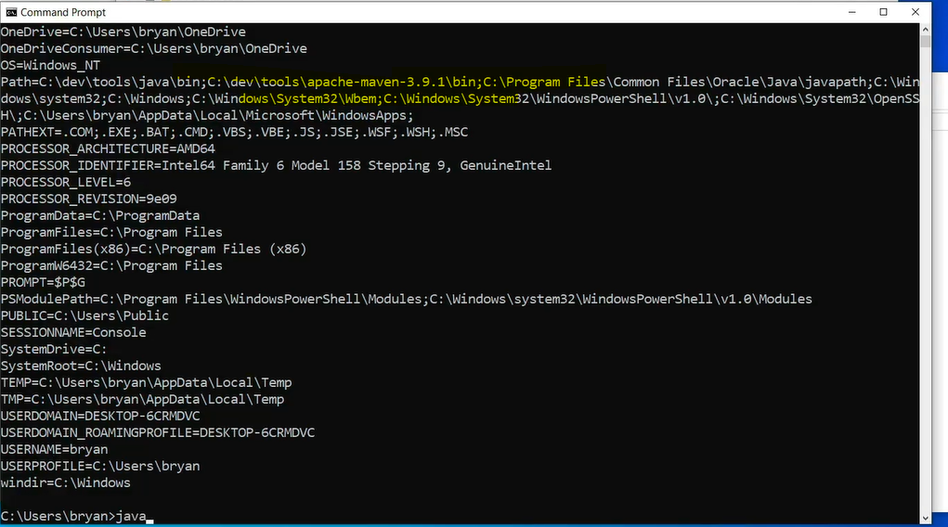

Checking java and maven version –

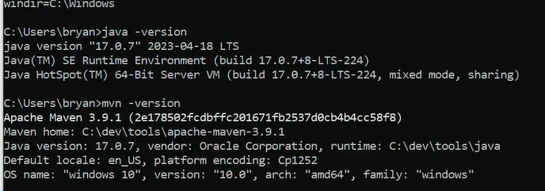

Maven prefer ProjectName -> src -> main -> java folder directory structure.

Sample POM file –

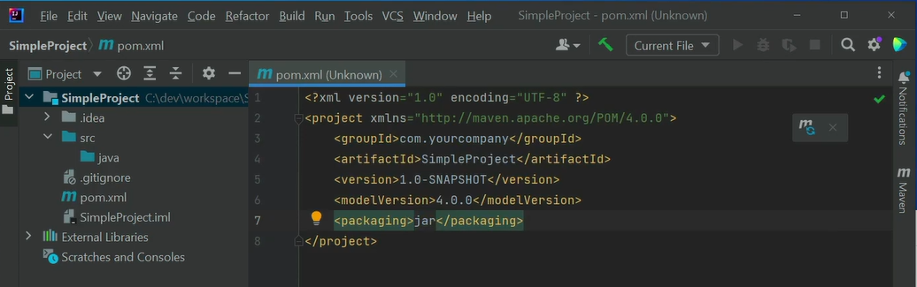

The “mvn clean” command will download all the maven needed package then “mvn compile” will download even more plugins and dependencies and compile our source code and will create a “target” folder which will contain our compiled classes –

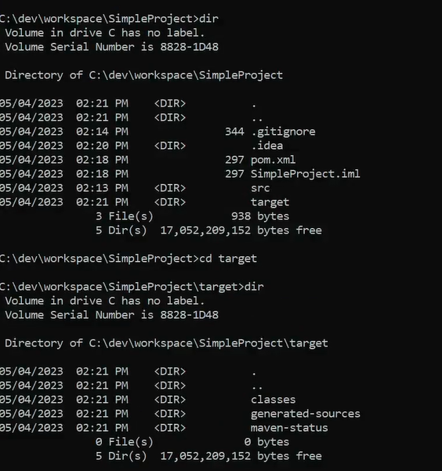

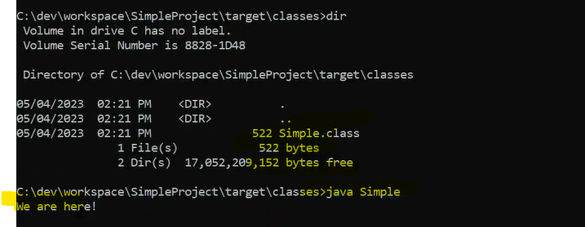

Ant is easier to learn, but it is only meant to be a scripting tool. Maven is centered around managing our entire project’s lifecycle, so versions, how we structure our code, generate information about the application.

Folder Structure – by default, Maven looks folder src/main/java and compile our code into target folder.

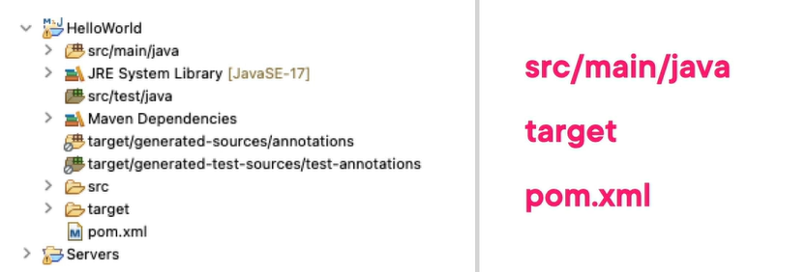

For unit test we can src/tests/java folder.

From the target folder only, we tests gets run. Also, in this folder our code gets bundled up i.e. package contents by running command “maven package”.

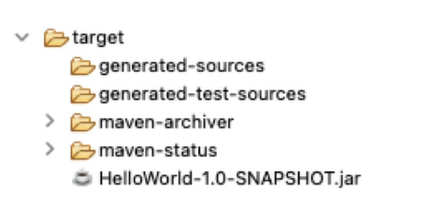

The pom.xms file structure – artifact name is like application name. while mentioning any dependencies, we need to know groupId, artifactId and version information for it.

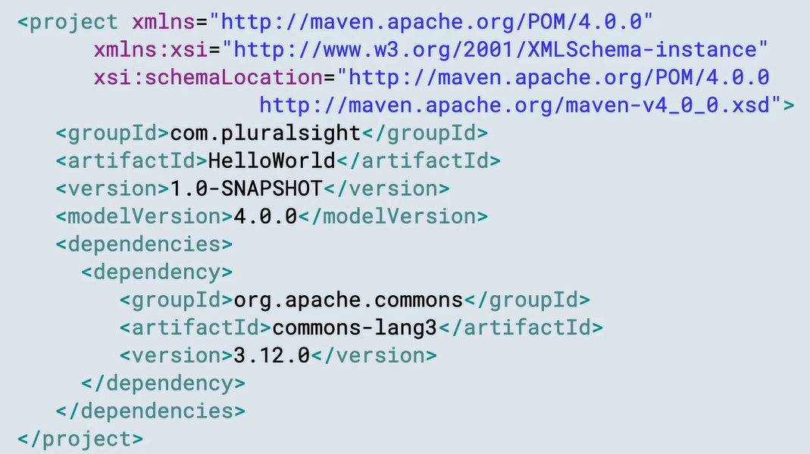

Packaging is how we want to distribute our application, is it a JAR, WAR, EAR, RAR, or POM or BOM file.

We can see those dependencies in the External Libraries reference folder – we can use “maven clean” and “maven compile” commands.

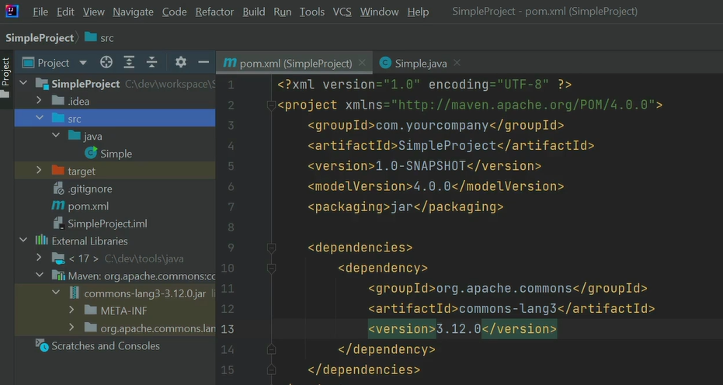

Maven default goals – clean (deletes the target directory and any of its generated sources), compile (compile all the source code), package (run compile first then package), install (run the package command and then copy it into our local repository for which default directory is home_directory/.m2), deploy (runs the install command and then deploys it to a corporate or remote repository)

The m2/repository is our local storage regardless of operating system types –

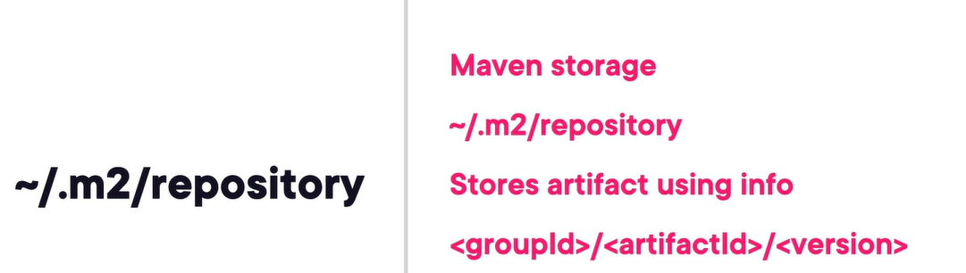

These folder structure groupId/artifactId/version helps us to avoid duplication as we don’t need to copy these JARs into every application we have, they can be reference from this location and avoid bloating the revision control.

Versions are the release number of the artifact that we want to use. All of our internal development should start off as a SNAPSHOT. If we want to get the latest development code then we need to pull SNAPSHOT, also it allows us to push up new code to a repository or a development team every time. It saves us from rereleasing versions of development, we never want to deploy to production with a SNAPSHOT because we can’t reproduce or recreate the code.

Version terminology industry uses for snapshot and releases – milestone, release candidate, etc.

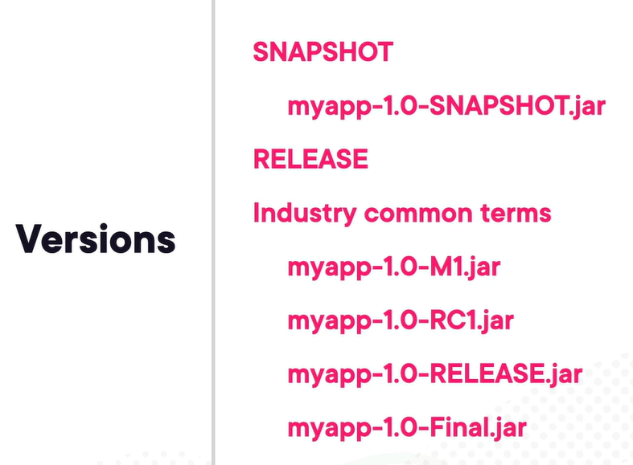

Packaging types – pom, jar, war, ear, maven-plugin. The jar, war, ear, rar and par are all just glorified ZIP files for all intents and purposes. The default and most often used type is JAR. If we use type as PM then all the dependencies inside that POM are downloaded into our application and they actually refer to it as a dependency POM or a bill of materials, it is widely used practice if we something like Spring Boot.

Transitive dependencies are the reason people have started using the maven.

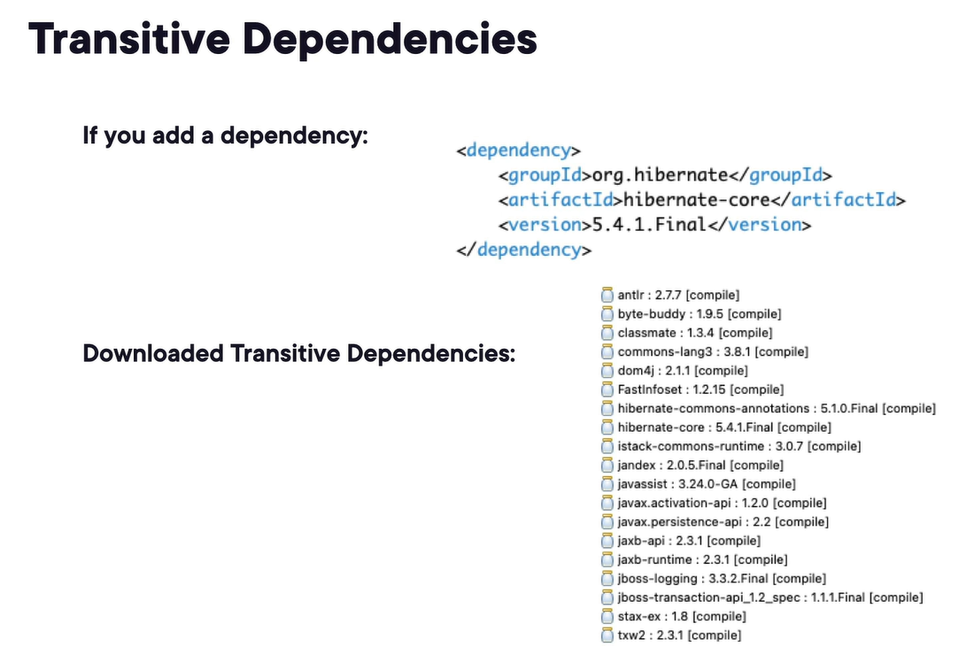

In maven, it provides six scopes for our dependencies - compile, provided, runtime, test, system (should never use this type), import. They will decide whether things get packaged or not get packaged into our final artifact.

We can see our dependencies into the dependency’s viewer, it will show which dependency is of which type –

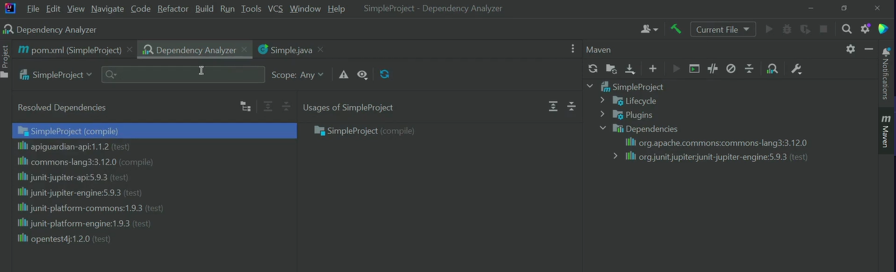

Maven Repo are what Maven looks at to download code and other artifacts from so that we can use them inside of our application, we have dependency repo and plugin repo.

Maven first checks the local repo ~/.m2/repository otherwise downloads it from remote repository. From last few years, window has started to allowed Linux or UNIX style paths so these paths should work whether you are on a Windows or Linux or Mac system.

Super pom.xml file is located inside of our Maven installation.

Company generally used a corporate repository to keep their internal package like Nexus Repository (this is what central is) and Artifactory (Jfrog).

Dependency repository – where we download our dependencies, contains release and/or snapshots, can have in separate repositories.

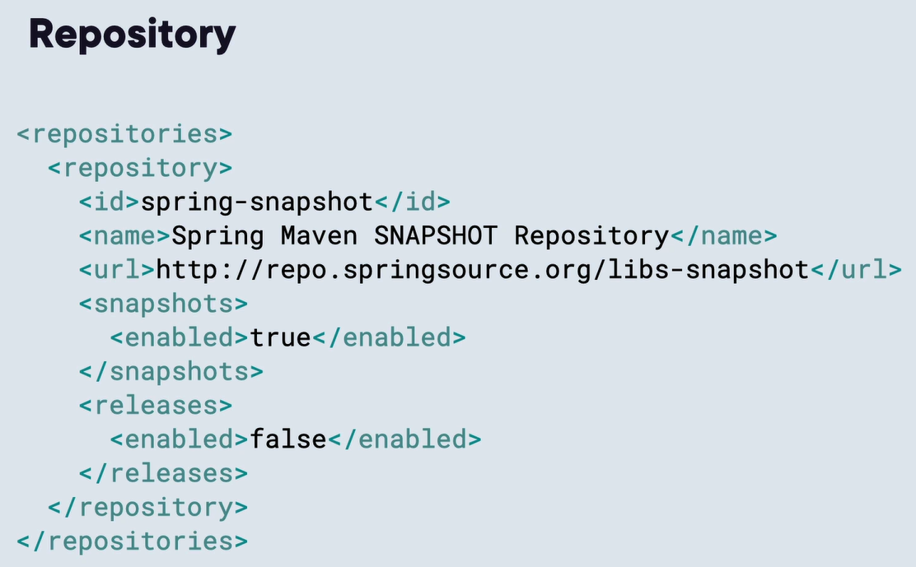

When we download or grab a snapshot version, it will grab the latest timestamp version from that SNAPSHOT folder unlike the releases version where we specially get the file with that version –

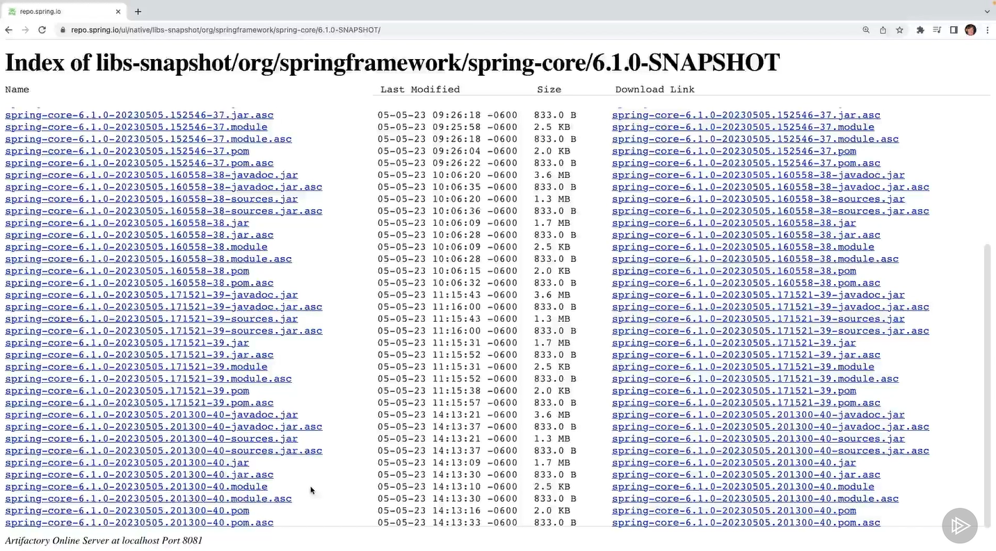

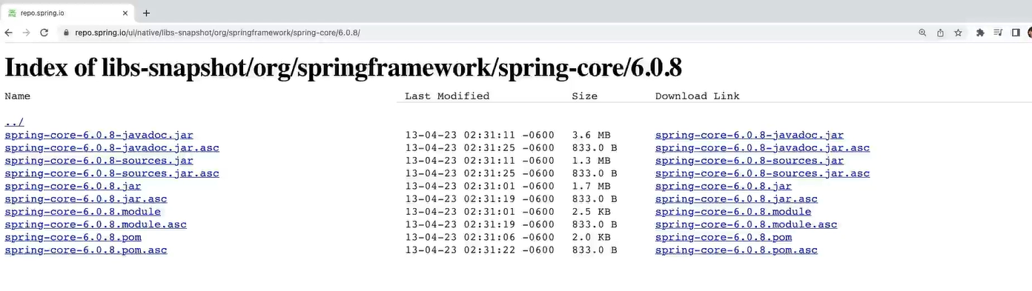

Adding a repository and its dependency –

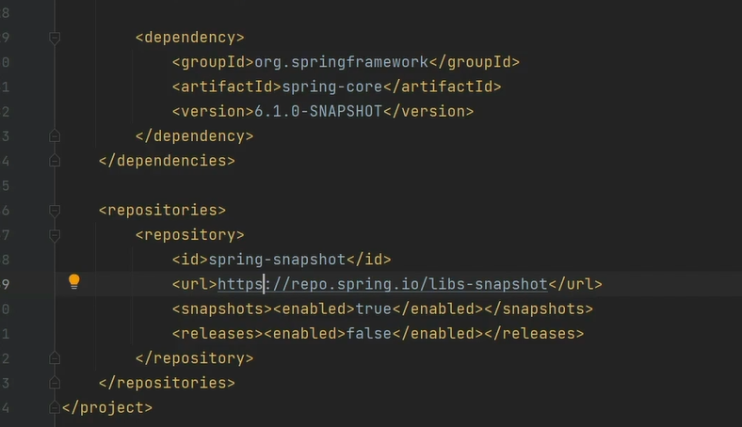

Plugin repositories are similar to dependencies repositor, but they just deal with plugins. We look for plugins into a different just a code cleanliness thing.

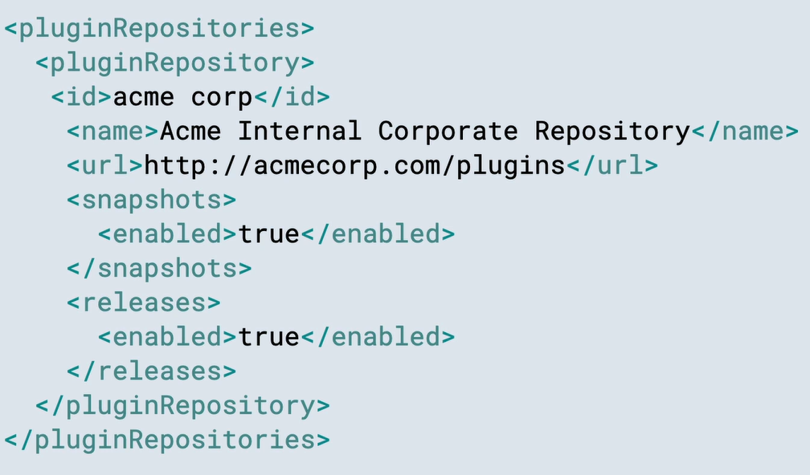

Goals are just plugins configured in the Maven install like clean, compile, install, etc. defined in super pom which gets inherently added to the effective pom i.e. our project pom. We can tweak these plugins.

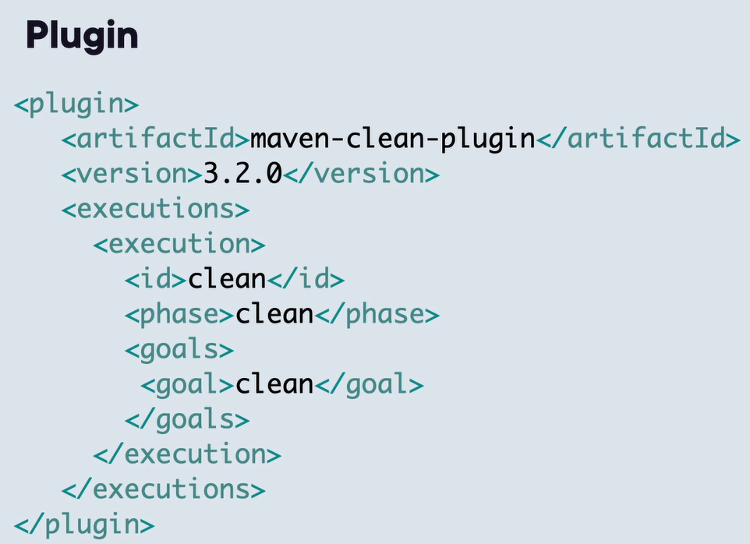

Phases – validate, compile, test, package, integration-test, verify, install, deploy.

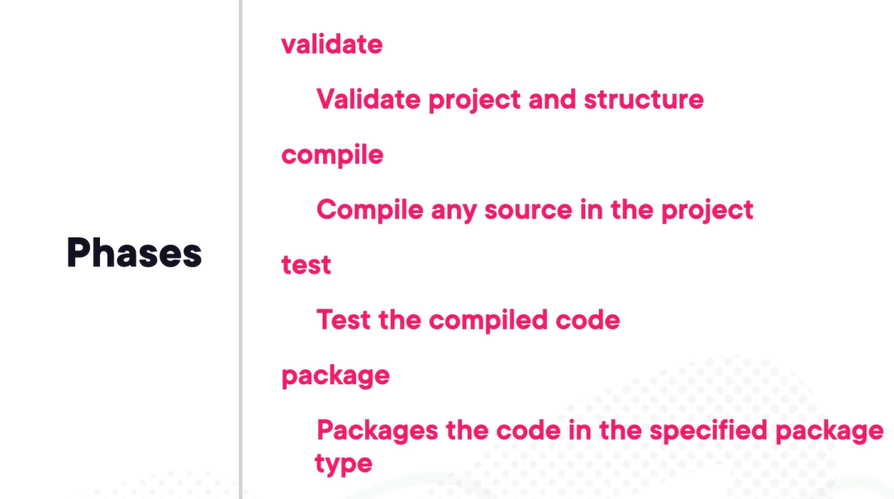

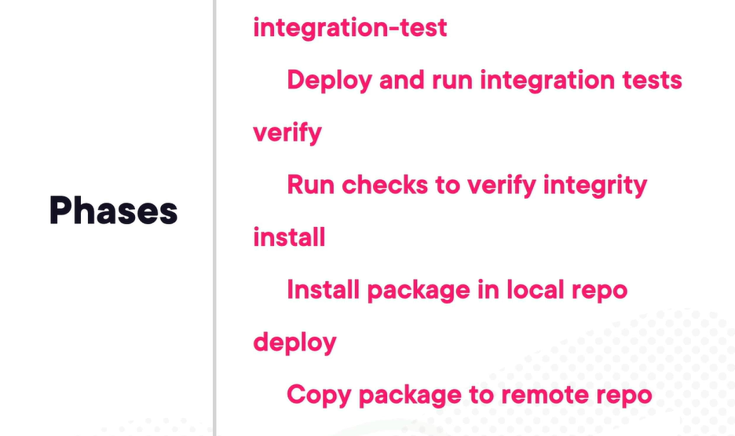

Compiler plugin – it invokes javac but do lot of other things on top of it.

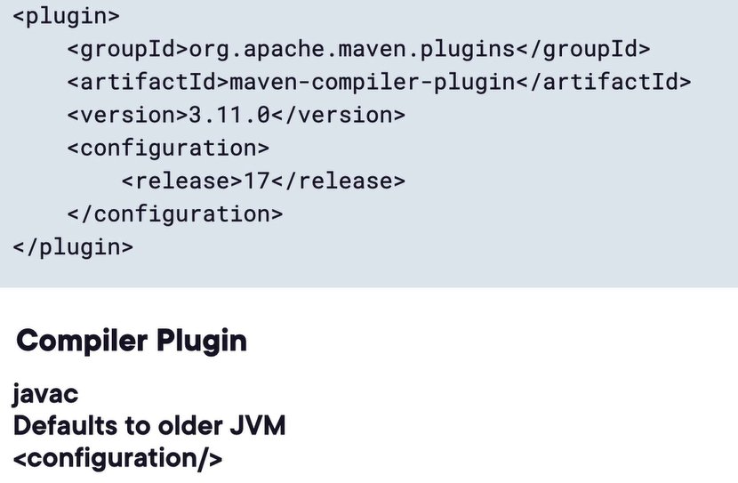

Adding the compiler plugin –

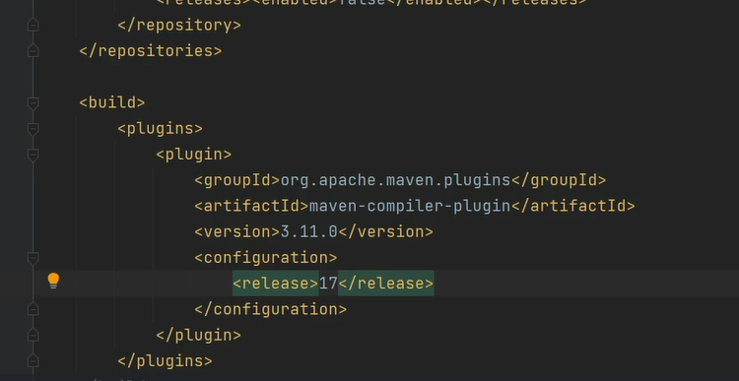

Jar plugin – it is used to package our code into a JAR file and tied to the package phase of our build lifecycle. It will also create manifest file.

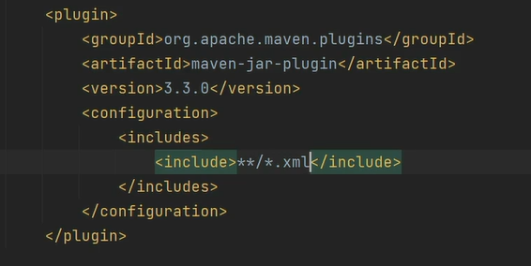

Source plugin – it packages up our source code so that we can distribute it for context-sensitive help inside of our IDE or to make some more code-intensive Javadocs. It is also tied with the package phase.

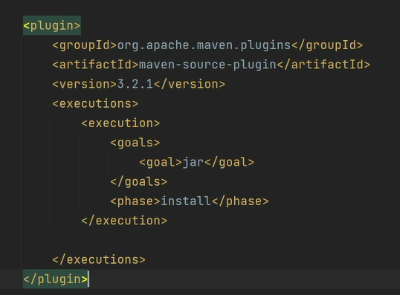

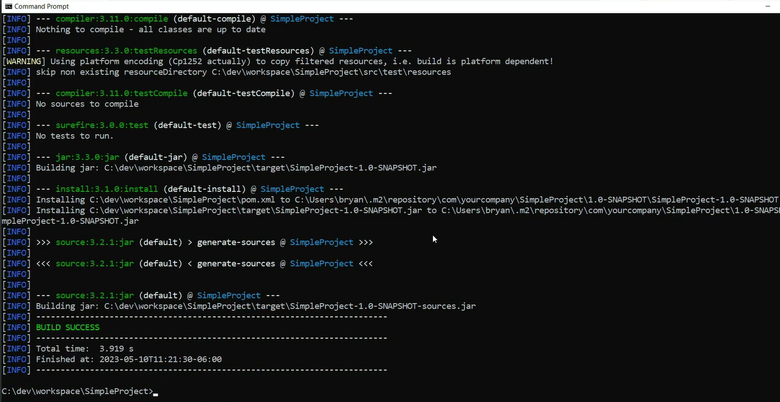

It will create snapshot and snapshot sources jar files.

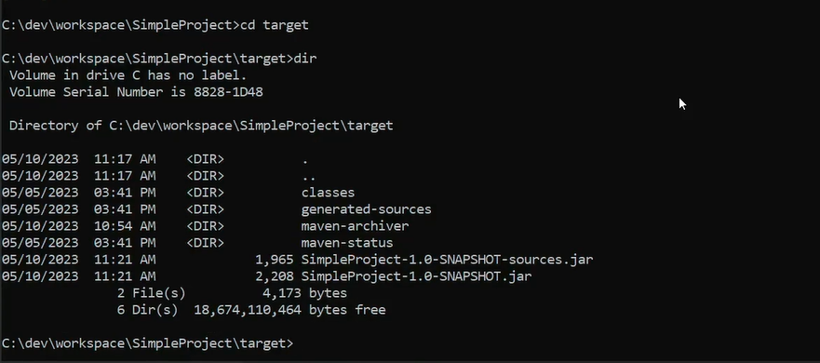

Javadoc plugin – tie to package or later phase like verify –

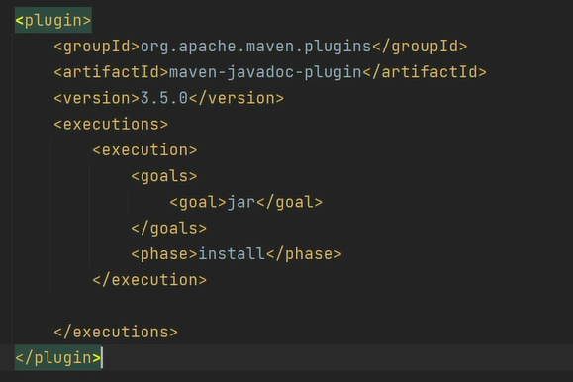

It will create the javadocs for us –

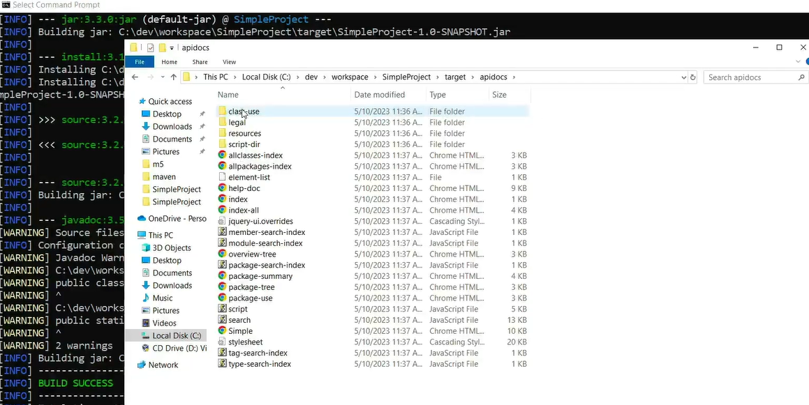

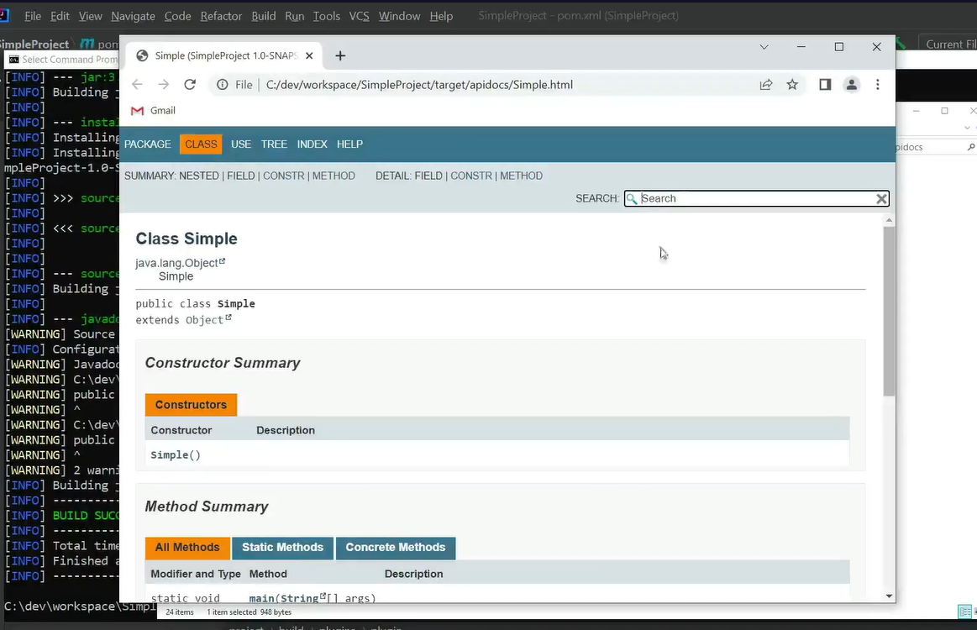

We can download the source from the Javadoc site in our IDE to get context-sensitive help with or share it to other developers to our team. The source file help other team’s developer to identify what code it is tied to and why it is breaking if they refer our source code in thar application, they can step through that source code which makes a lot easier for developers. This is very important for micro service architectures and having separate teams work on separate pieces of the application.

Goals are just configured plugins inside of our application which are coming from the super pom files with default configuration, but we can override them in our application though. The compiler plugin and jar plugin are by default available.

IDE integration – dependency management,

Instead of typing the dependency in the dependency tag, we can do it from the window itself, it will add the dependency section automatically –

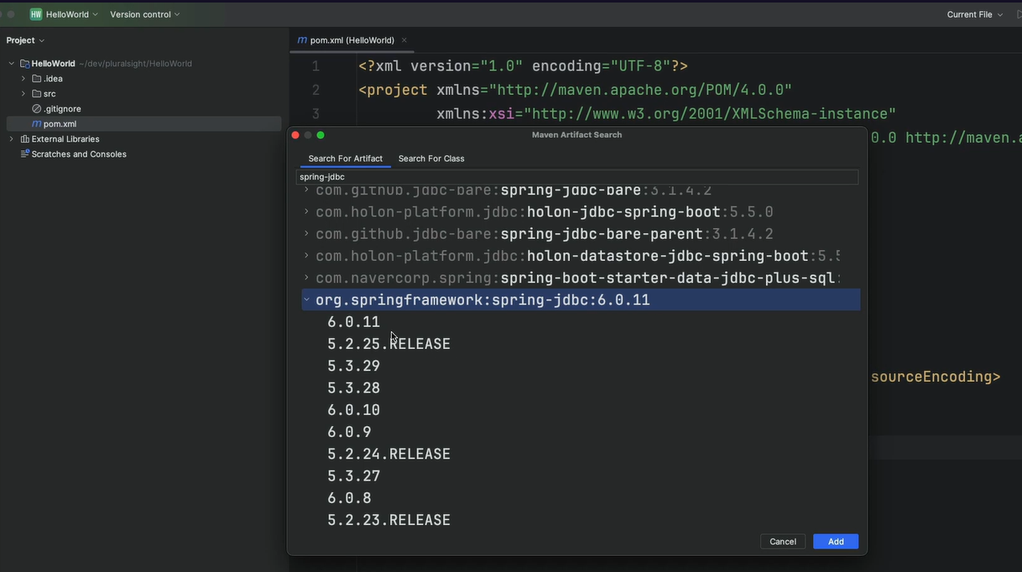

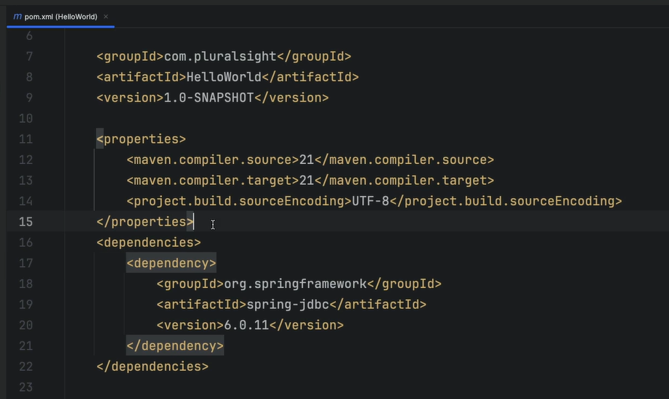

Profiles – it is a useful tool to setup environment-specific build properties. They can be configured either in the pom.xml or settings.xml files. We can use it for example like database or database connection based on the environment through profile settings.

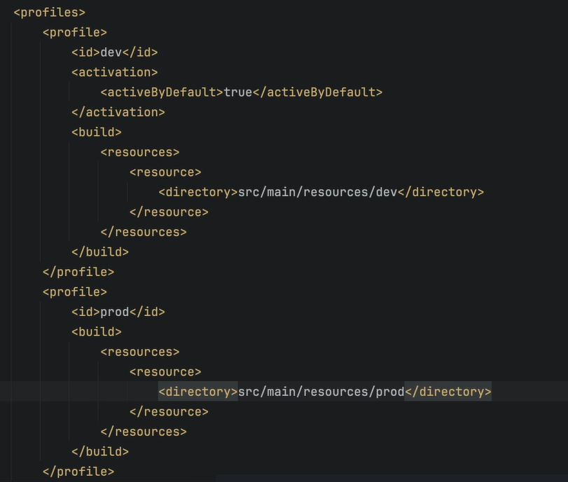

By this we can have resources in different directory or files in different directories which we can copy over to the target folder.

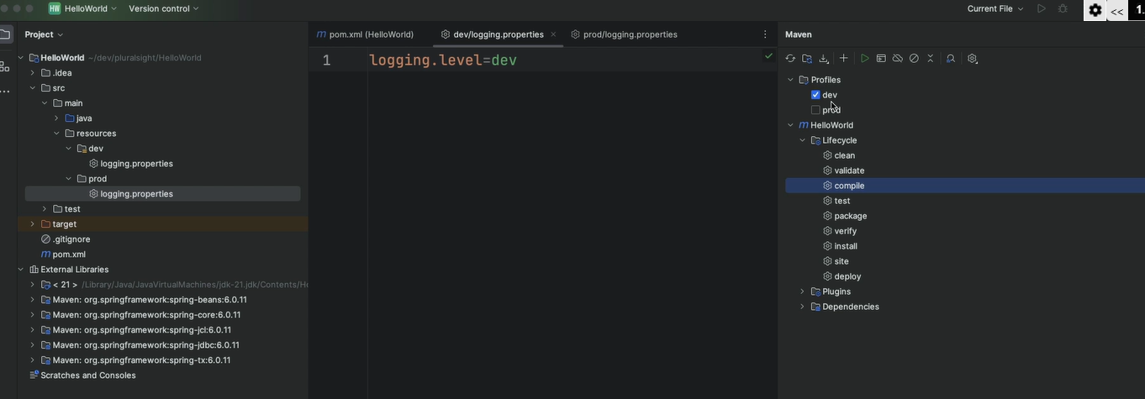

Dependency Hierarchy – displays dependence, tree, including transitive and overridden scope –

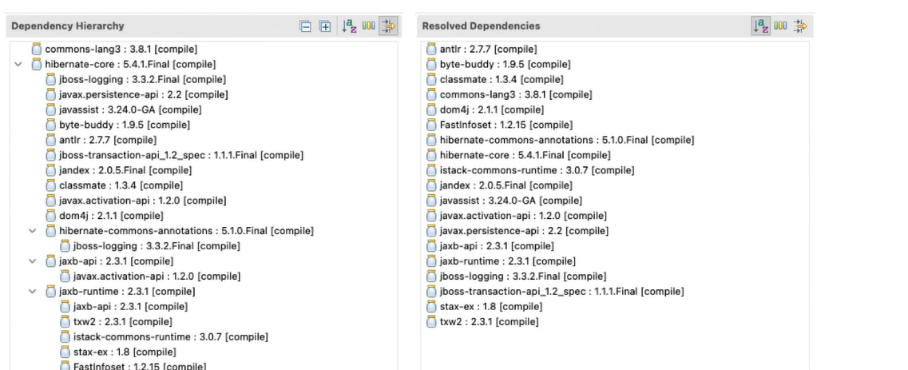

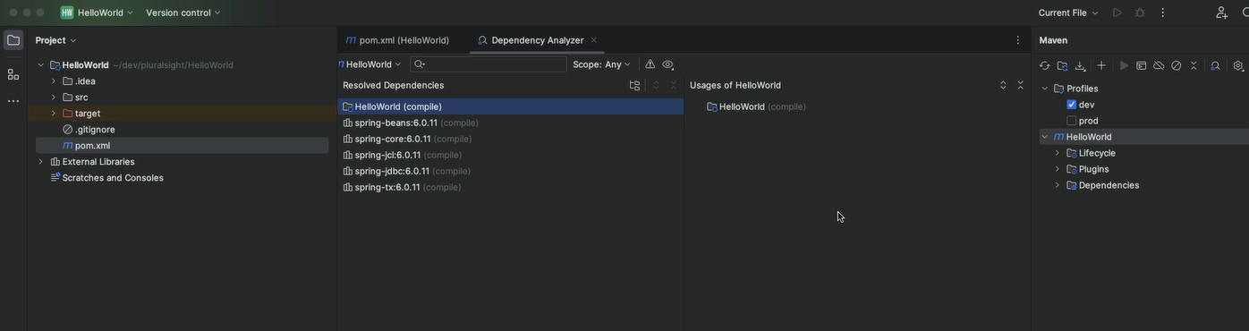

Effective pom – complete POM, including inherited settings, debugging tool, it is something maven runs inside our application. It is combination of the all POM files like any of the projects that we have imported, any settings we have in our settings.xml, maven has a POM file itself.

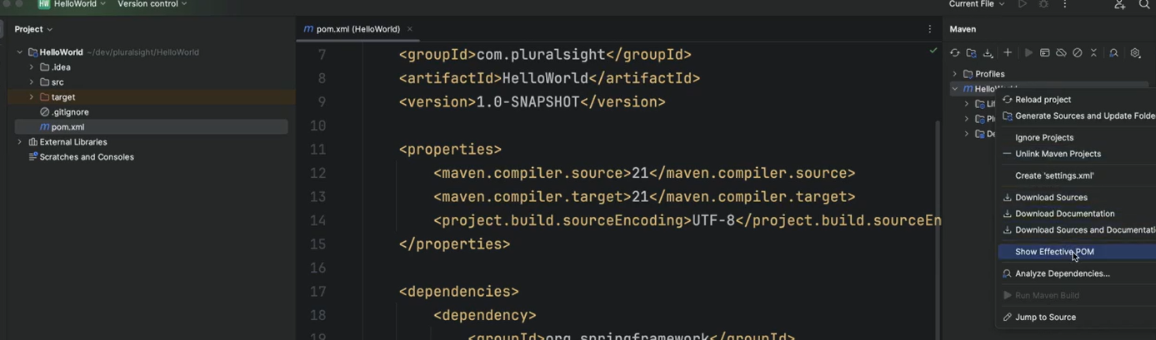

Multi-module project – it contains a parent project like web service module and a sub project like web service client module and web service server module.

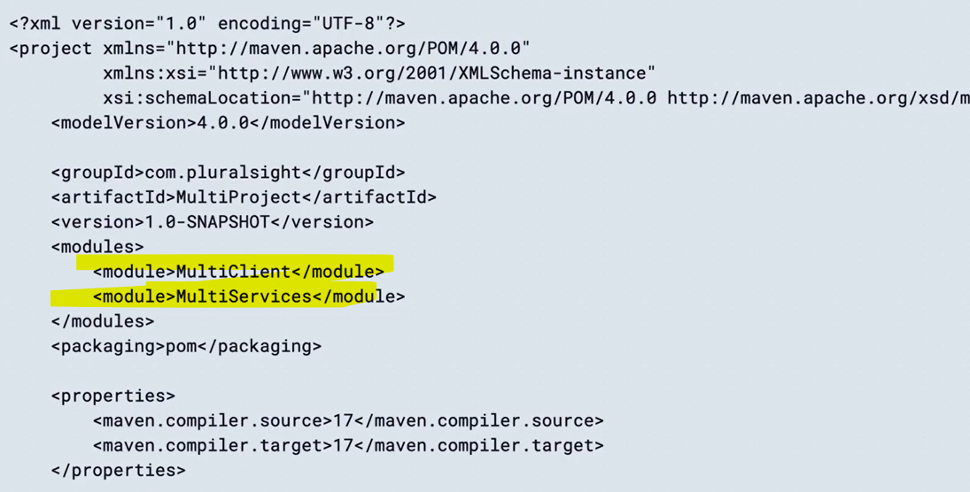

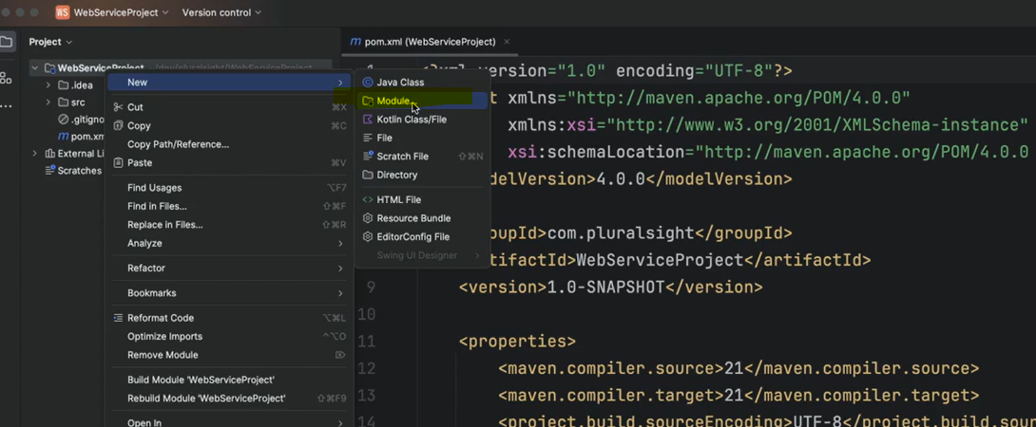

By this we can share the code between two projects as a shared contract and dependencies among the projects.

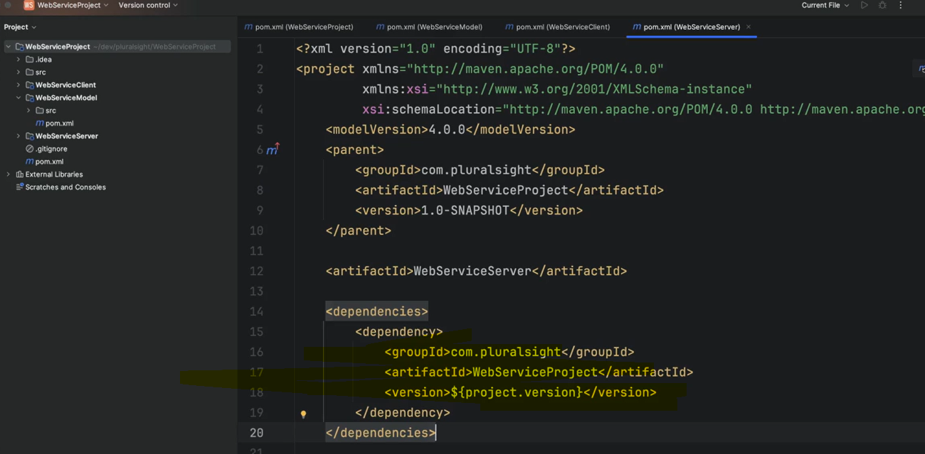

Using a BOM file, it is a parent POM file. A lot of frameworks use a bill of materials files to distribute their library with the appropriate dependencies. The most common use case of this is Spring boot and the Spring Framework.

In BOM, it is like parent POM file, but we are just utilizing the dependency part of it. The packaging type set as POM and then we use the dependencyManagement tag.

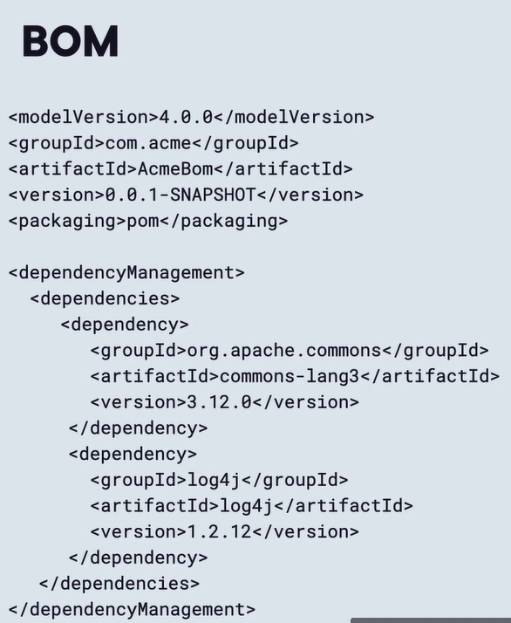

We can just create the dependencyManagement section in the parent POM file. It will just become the BOM file –

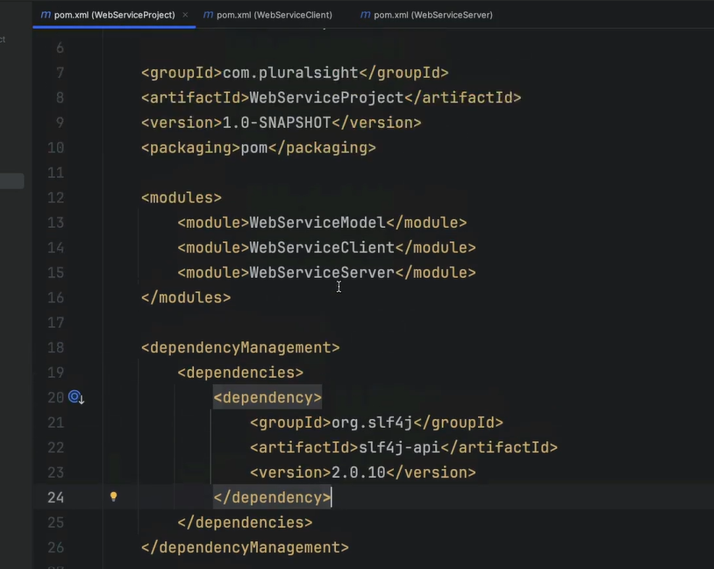

In java, if we have a one parent file then we can’t create another parent as only one level of inheritance will work. Importing a BOM file we can use below –

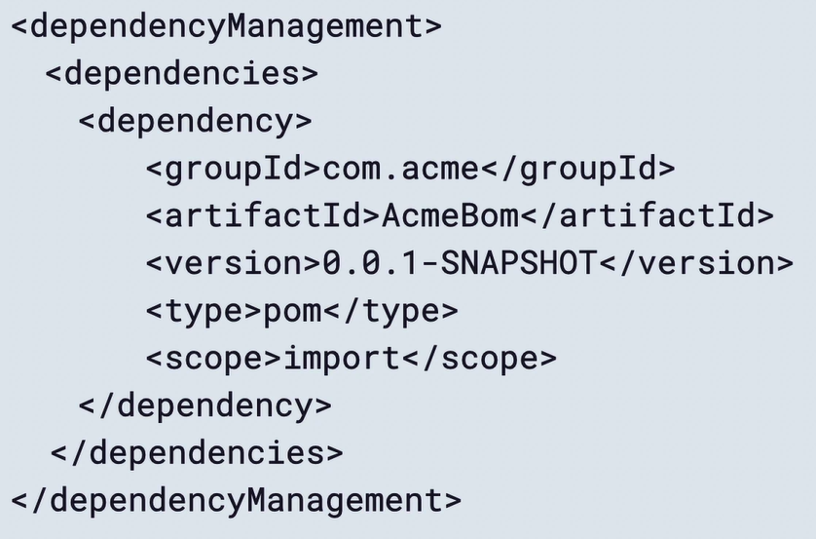

We can even import the Spring Boot starter parent as it is just a POM file. It is its own bill of materials file.

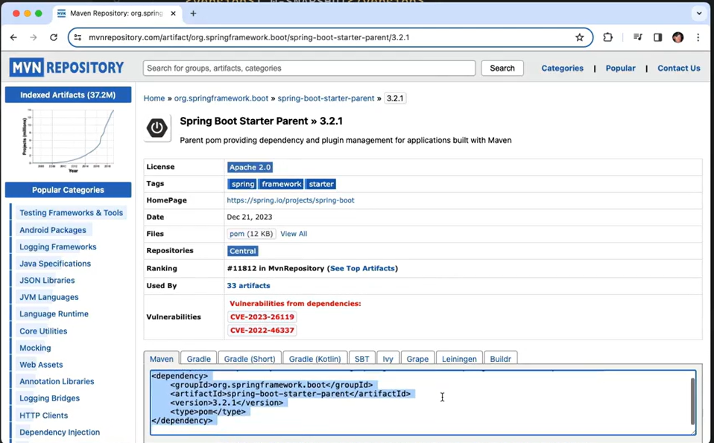

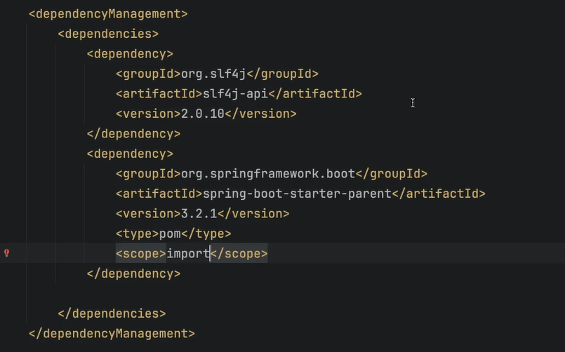

Due to above all the child module in a multi-module project setup project can utilize this Spring Boot Starter libraries. So now we have access to all of those libraries and all of that dependency management in our child module without having to go change the parent to something different. So we can utilize our hierarchical structure and their dependency management inside of our submodule projects. It is very effective use of bill of materials and importing that project in and a multi-module project –

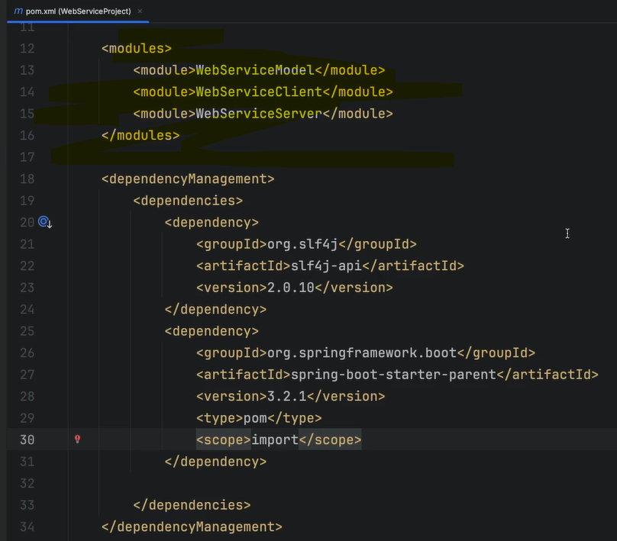

# Spring Framework: Aspect Oriented Programming with Spring AOP

AOP separates business logics from cross-cutting functionality, common uses are logging, user rights check, transactions, exception handling, caching, tweaking a legacy application.

Aspects – do something before the method, call the method, do something after the method. A aspects represents the modularization of a concern that cuts across multiple classes like logging.

Key terms – aspects, join points, advices, pointcuts, target objects, introduction, AOP proxy, weaving.

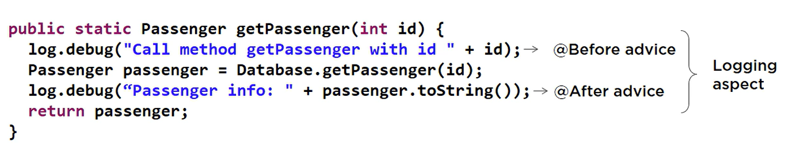

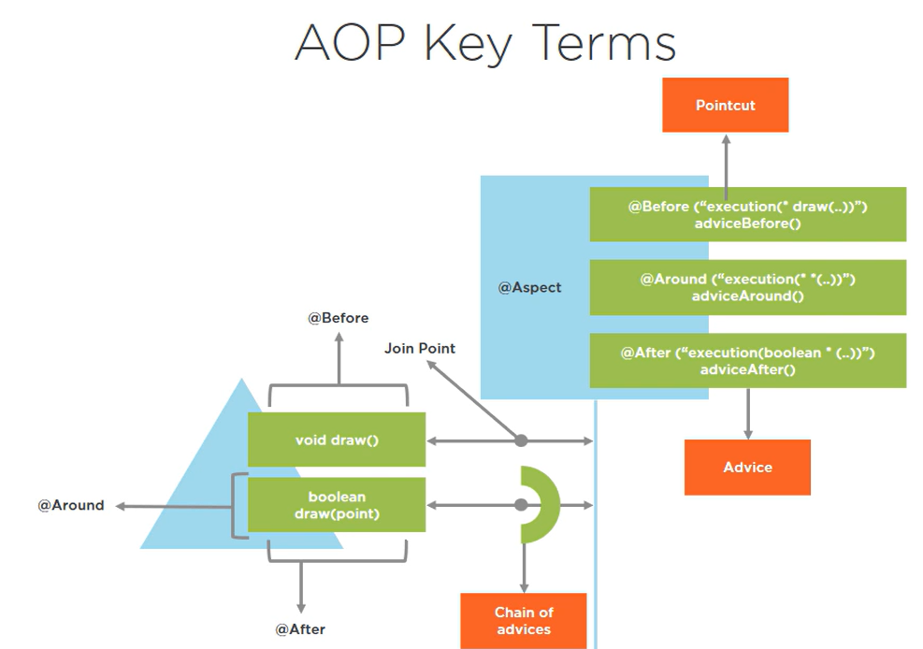

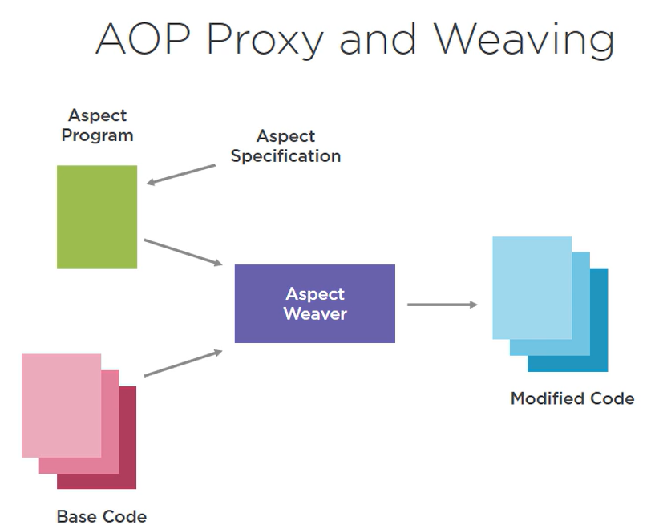

XML schema-based spring AOP –

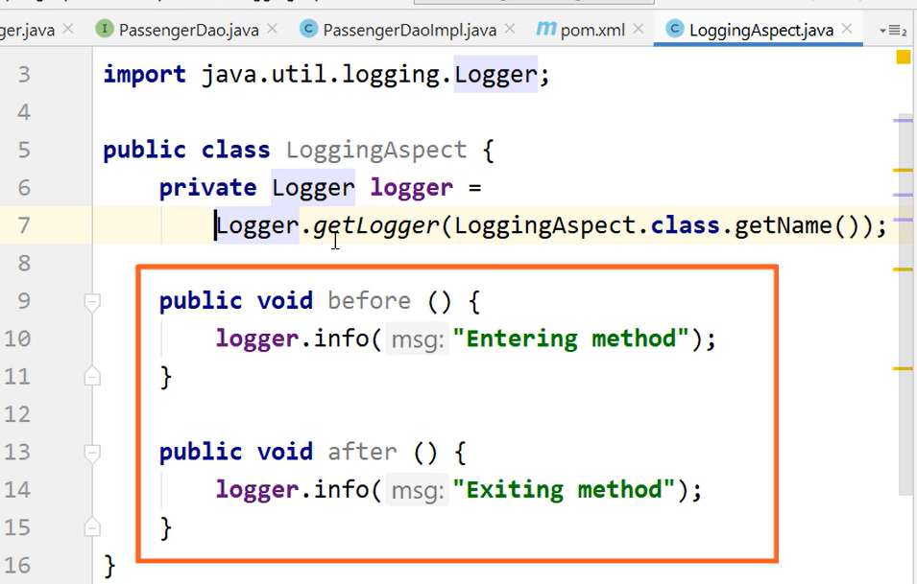

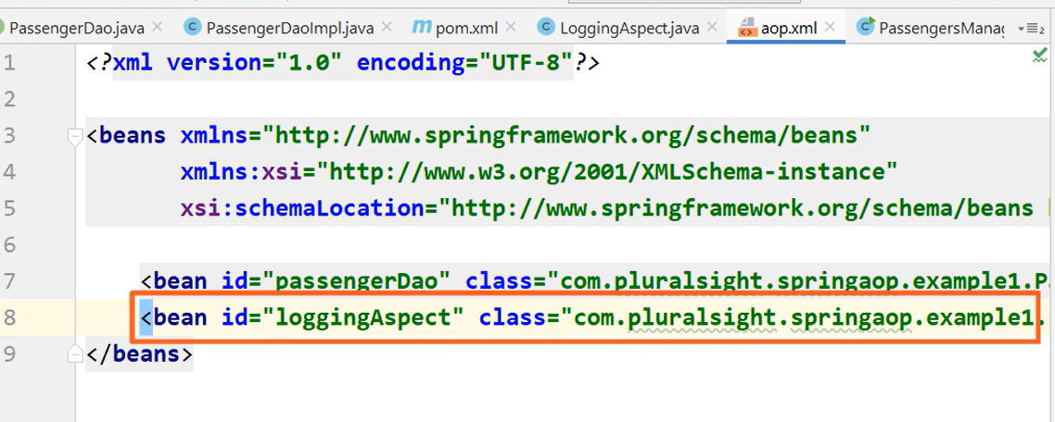

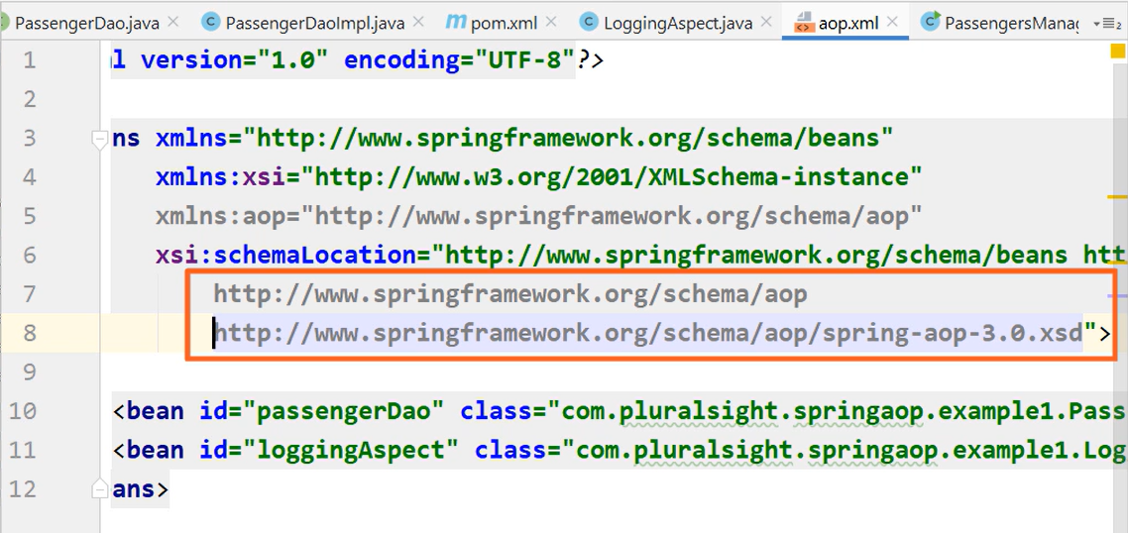

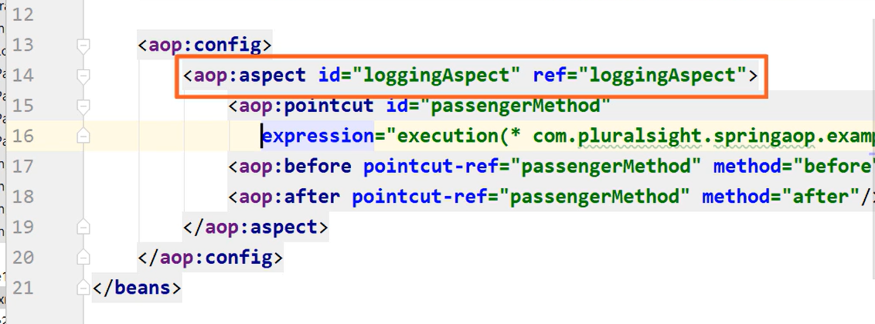

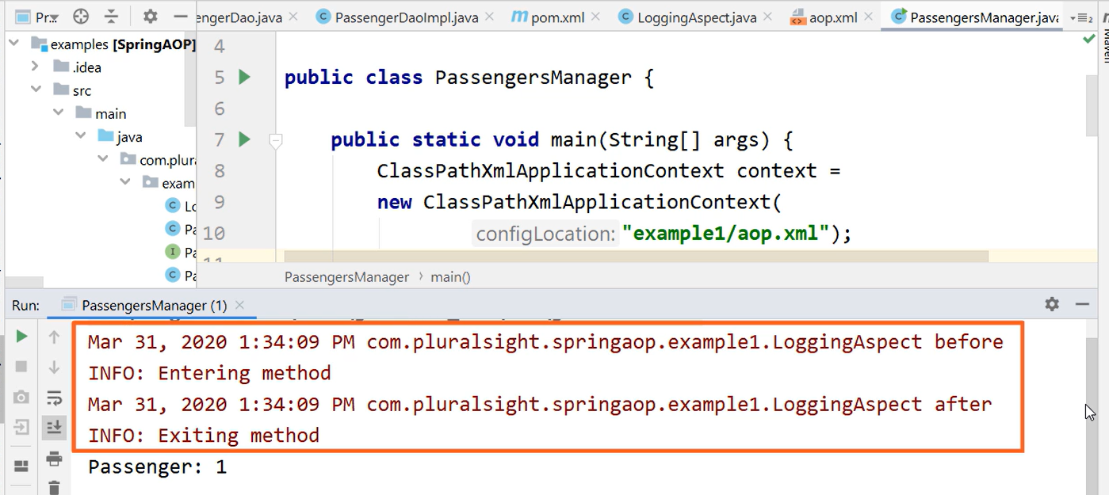

Using the AspectJ @Before and @After annotations

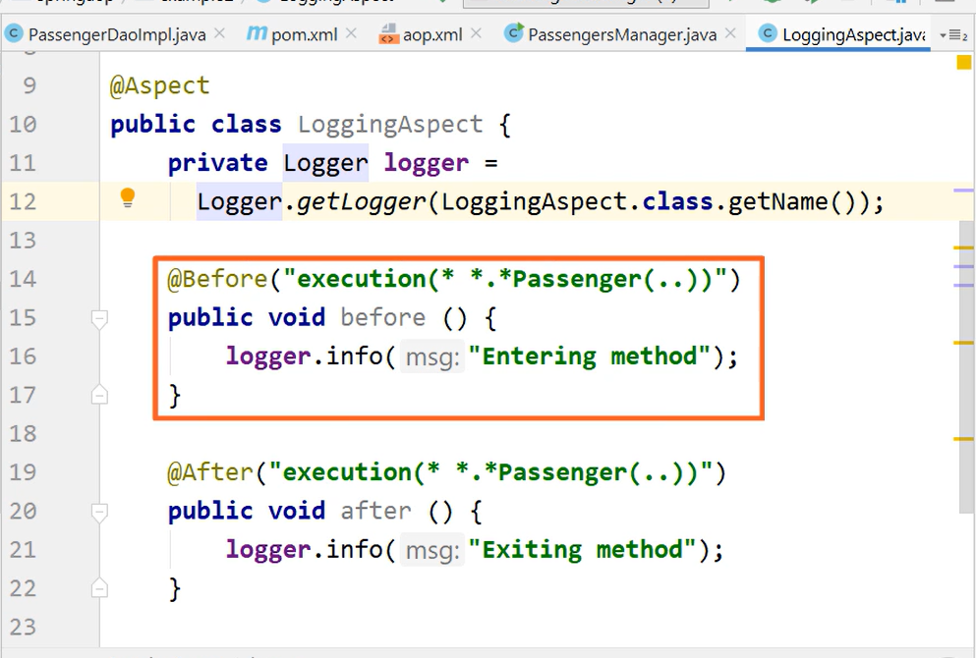

The @Around Annotation and the AOP mechanisms –

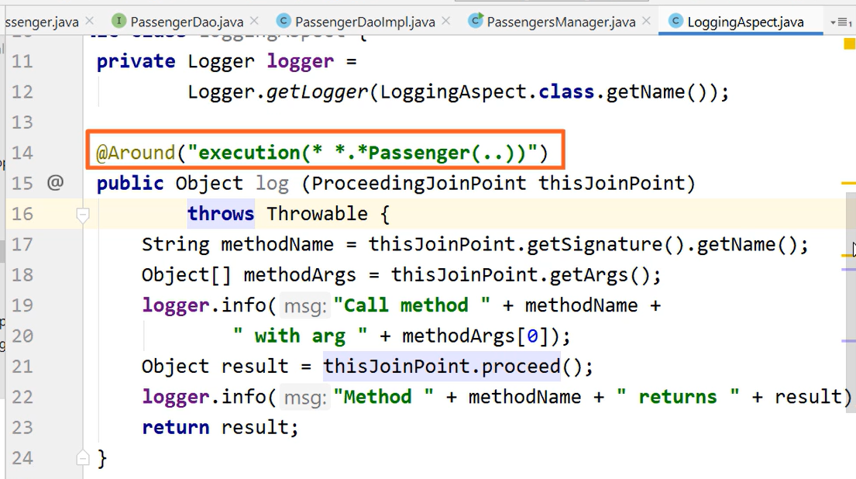

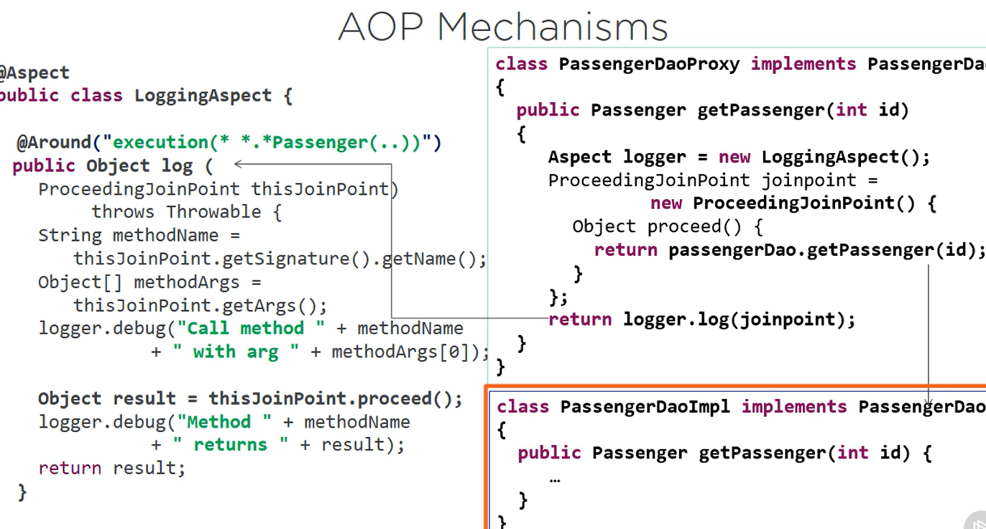

Orthogonal behavior for normal execution and for exception –

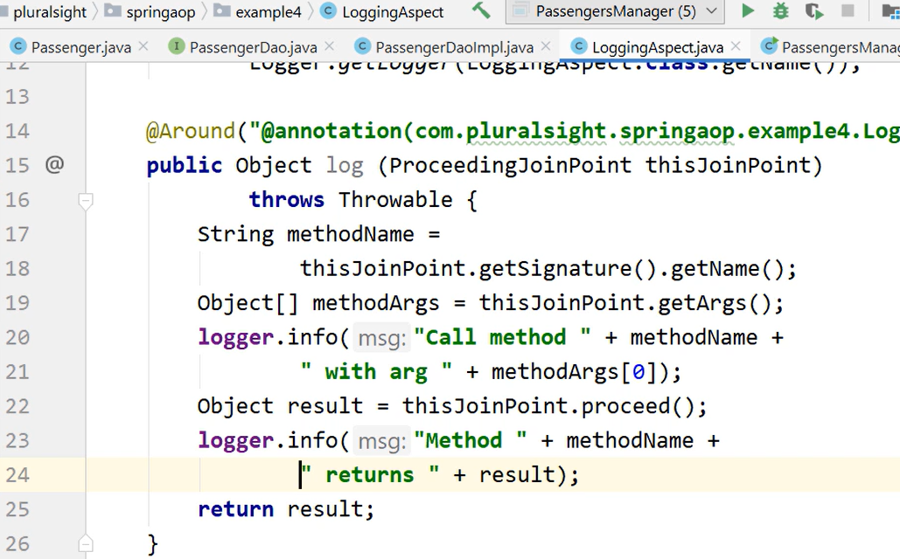

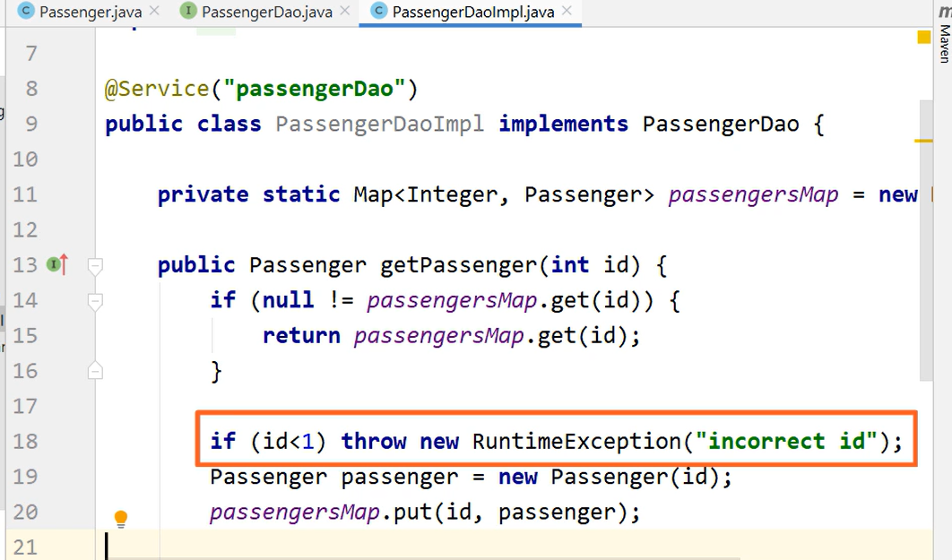

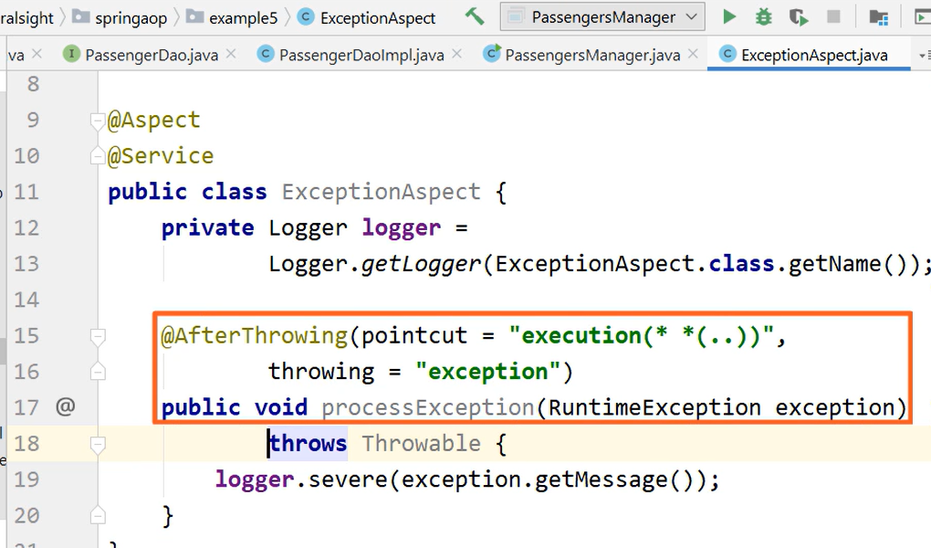

# Playwright Foundations with Java

Timeline of web testing framework –

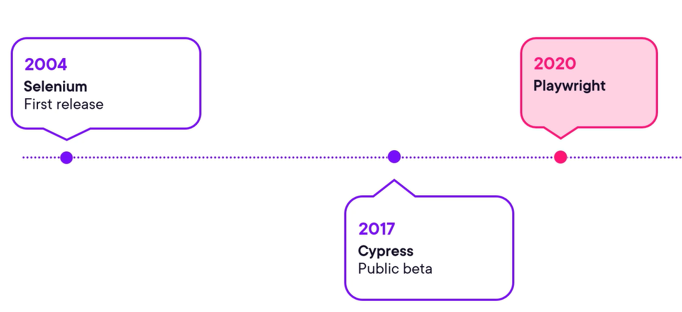

Advantages – auto-wait and stabilization, test isolation and parallel execution, failure retries, screenshots, debugging tools.

Playwright config file –

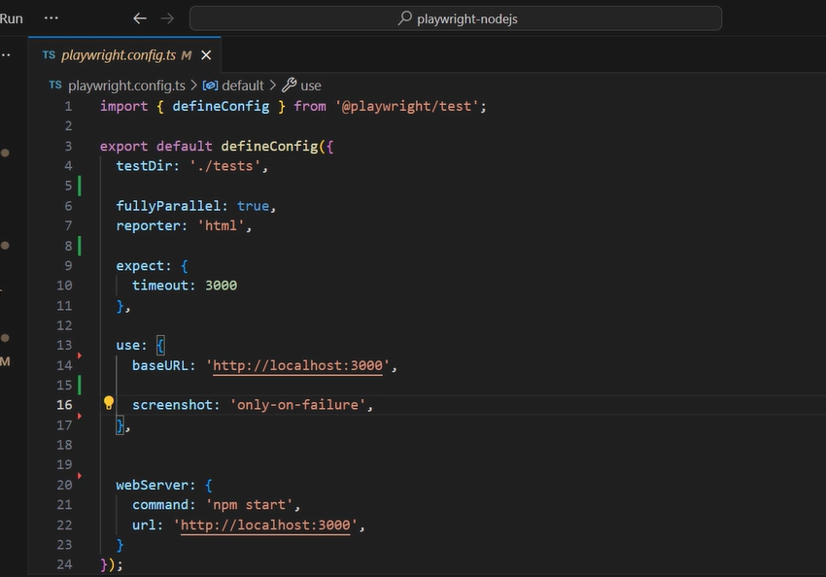

Playwright use concept of browser context, like virtual containers that isolate browser state such as cookies, storage and history which makes creation and teardown of context much faster.

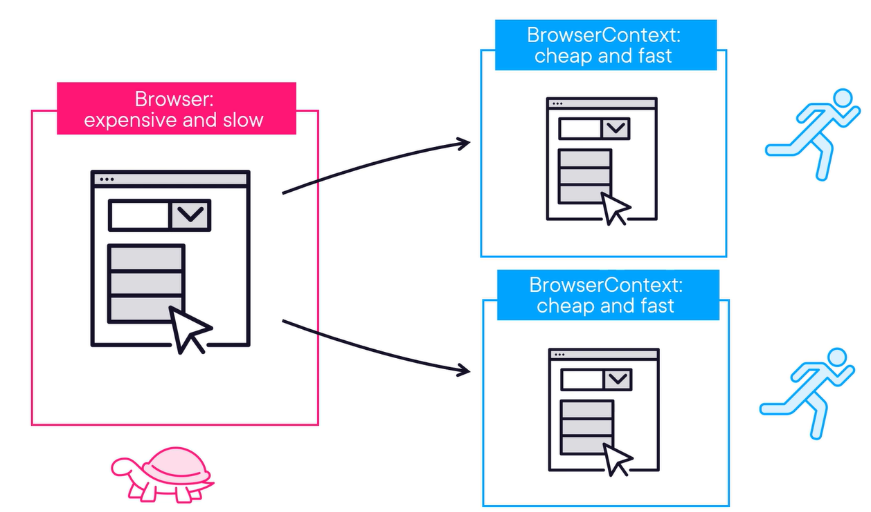

It is backed by Microsoft.

Junit 5 to run the test.

Chromium is browser engine that both Google Chrome and Microsoft Edge built upon.

How a page object is created in Playwright –

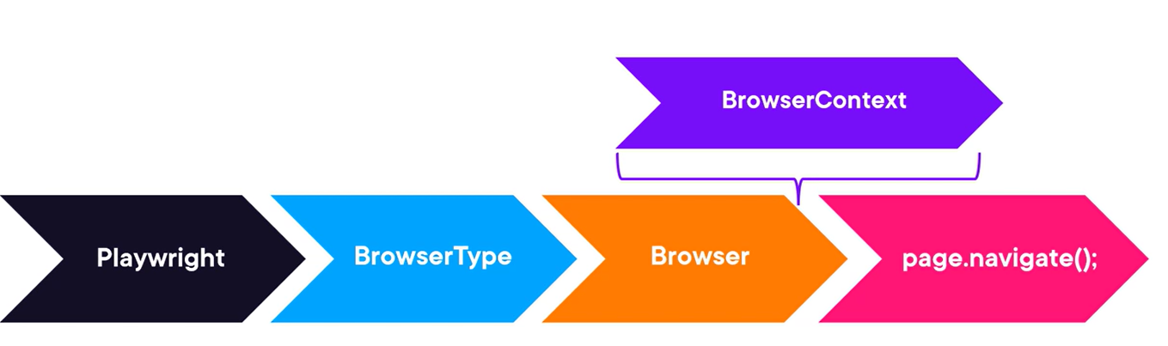

Wrapping the test into a try with resources function will guarantee that the browser and the pages will be closed at the end.

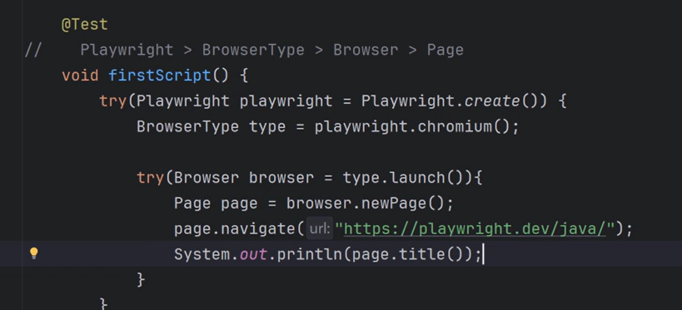

With modern Java code –

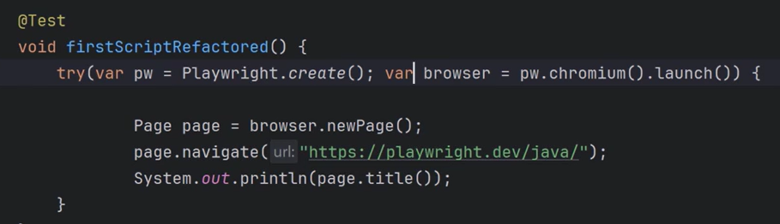

Using all the browser types – chromium, Firefox, webkit (safari)

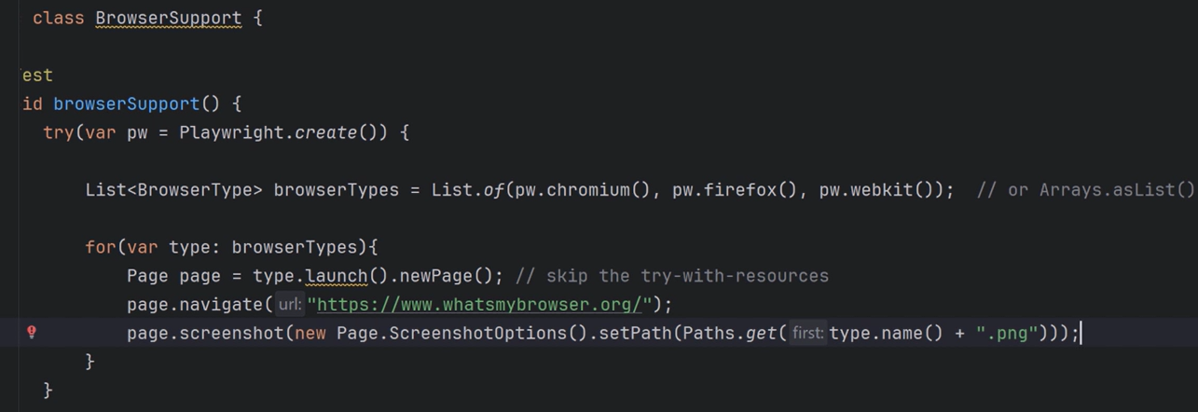

## Data Input Validation for Java Applications

External data sources – API calls from partner service, data read from a shared database, file uploaded by a user, URL parameter.

Types of vulnerabilities – sql injection, cross-site scripting (XSS).

Denylisting (flawed) vs. allowlisting –

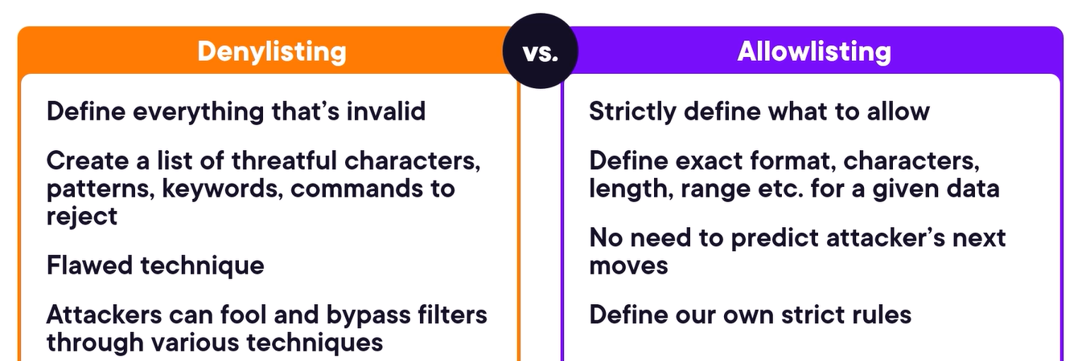

Allowlist for a range of a number –

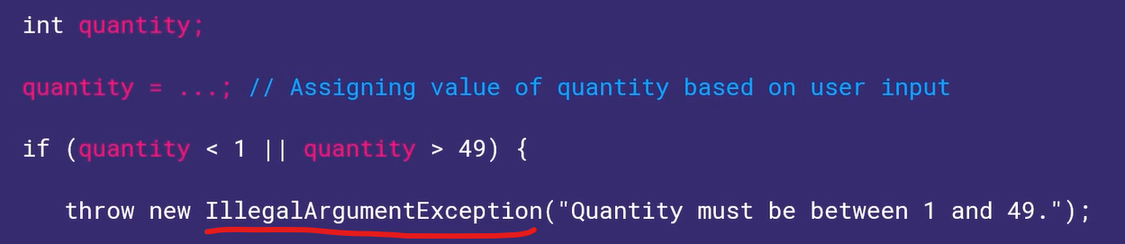

Use regex expression for string validation.

To have a safe string, we can do html safe encoding –

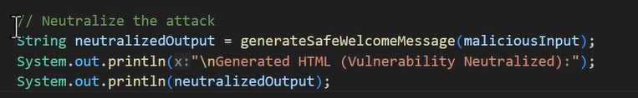

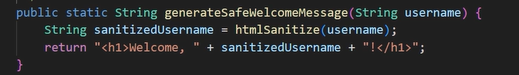

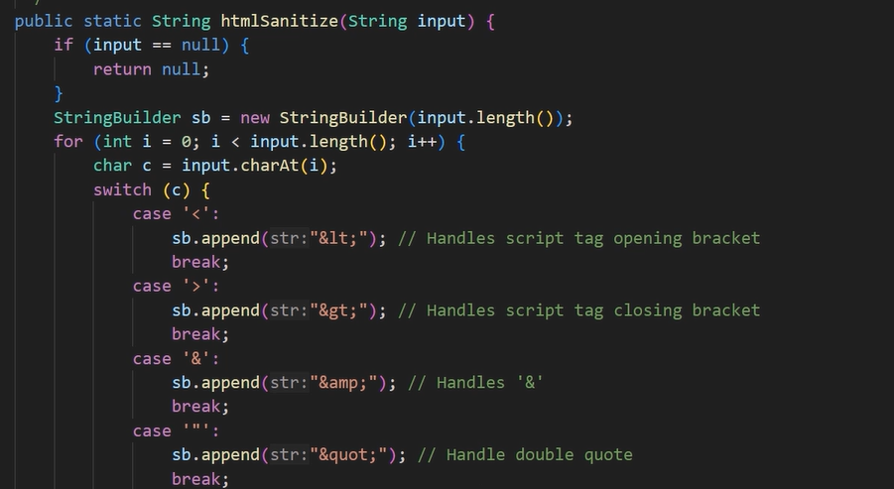

Rules alongside data instead of writing if-else condition like above for rules by using declarative validation, it is provided by the bean validation API aka Jakarta bean validation by providing setup of annotation. Hibernate validator is the engine that contains the implementation to enforce these rules, it is included by default with the Spring book framework –

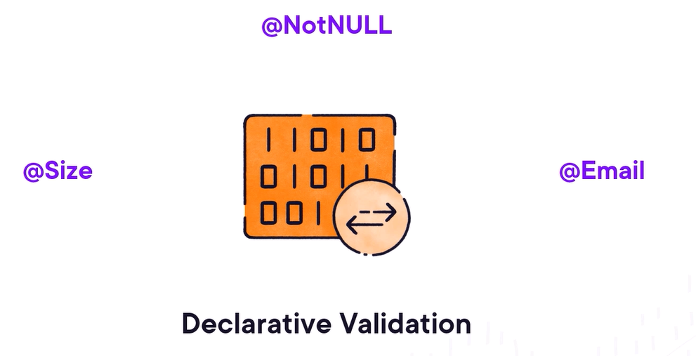

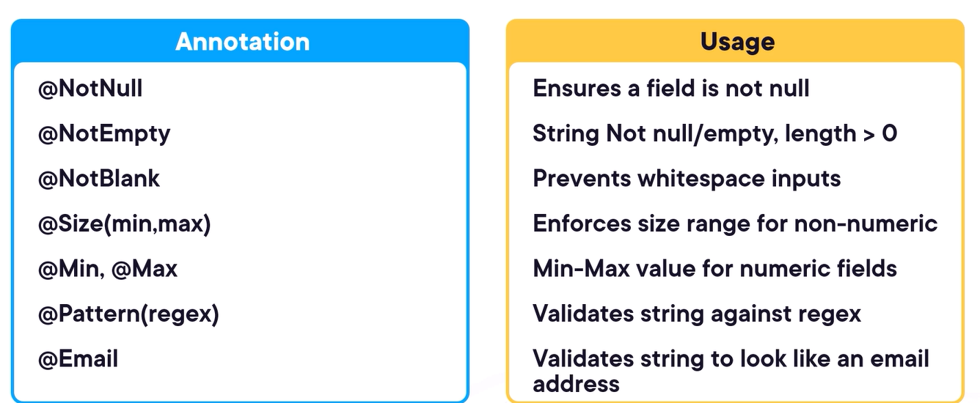

Sample class –

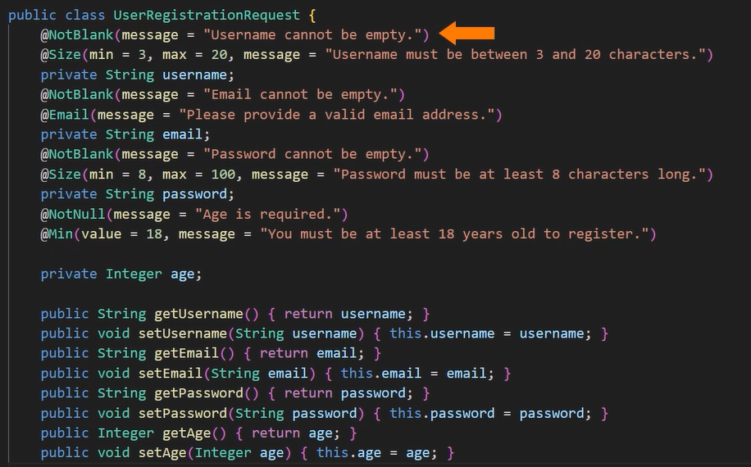

By using @Valid we are saying to Spring to take this incoming object and run it through the validator before it executes the code inside this method. In case of validation error it auto catches and throw the MethodArgumentNotValidException and sends “400 bad request” to the client.

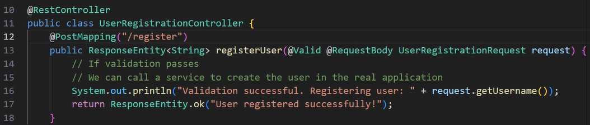

Using GlobalExceptionHandler –

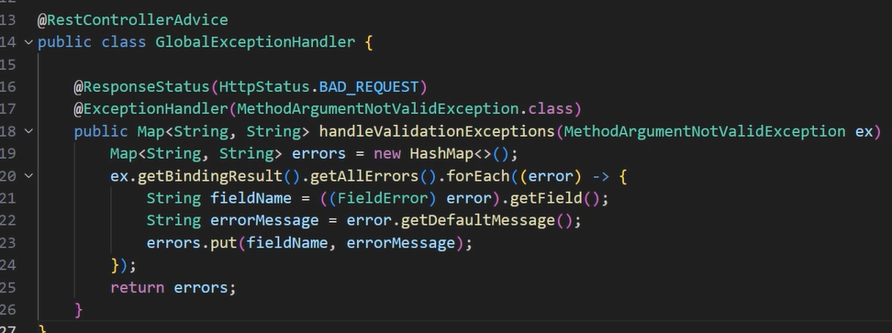

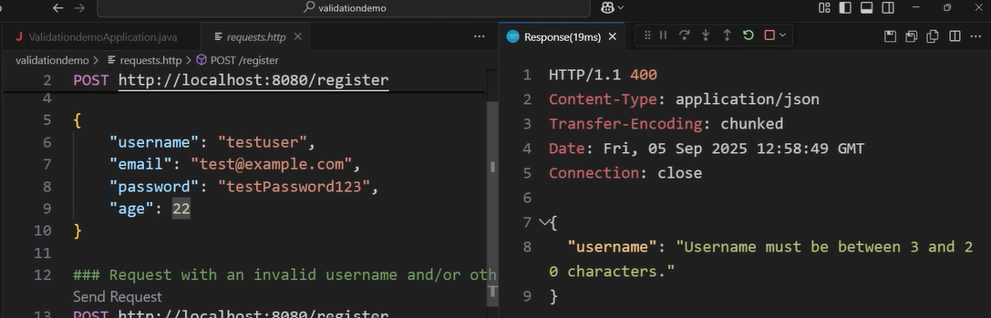

Custom Data Validation – the custom validation are needed when validation logic depends on multiple fields (cross-field validation) or requires a database lookup.

First – creating annotation -

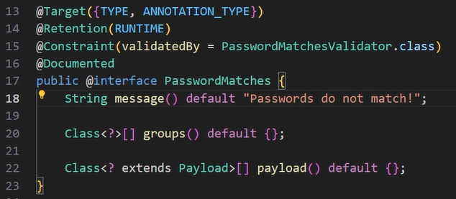

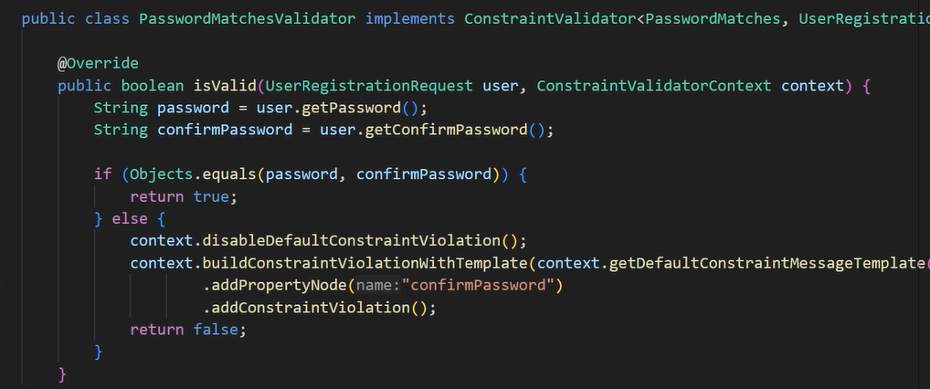

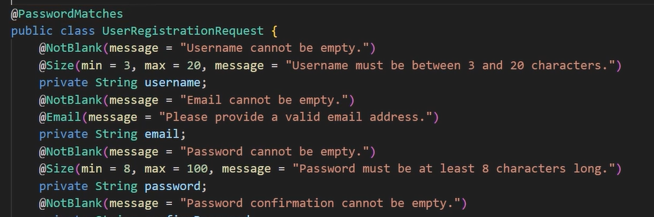

Best practice – file validation – check file size (set in application.properties config file), type of the file (by checking file header “magic bytes” in the beginning, can use libraries like Apache Tika or by creating allow list of acceptable file types), to check the file content like in case of jpeg we should consider it running through an image processing library to re-save it which often cleans up malicious payload or pixel bomb threat which can exhaust the server memory. If it is a zip file then checking the path traversal characters in the file names within the archive to prevent an attacker from overwriting system files.

Preventing insecure deserialization – serialization is the process of converting a Java object into a stream of bytes for example to send it over a network or save it to a disk. Deserialization is a reverse process means converting a byte stream back to a java object. If we deserialize the things from external source it can lead to remote code execution attack. To avoid this we should not deserialize untrusted data and avoid deserialization altogether and use safe data format like JSON for communication. If we must deserialize the use look ahead mechanism to create allow list of safe classes to be instantiated.